**Setting up VM BOX with multiple linux machines**

**This** document contains instructions to setup CENTOS MACHINES AND PLEASE SETUP CENTOS MACHINES

Install VMBOX from following link based on your operating system and 32 or 64 bit architecture.

<https://www.virtualbox.org/wiki/Downloads>

Note** You can always check if your system is 32 bit or 64bit, by right click on my computer>properties

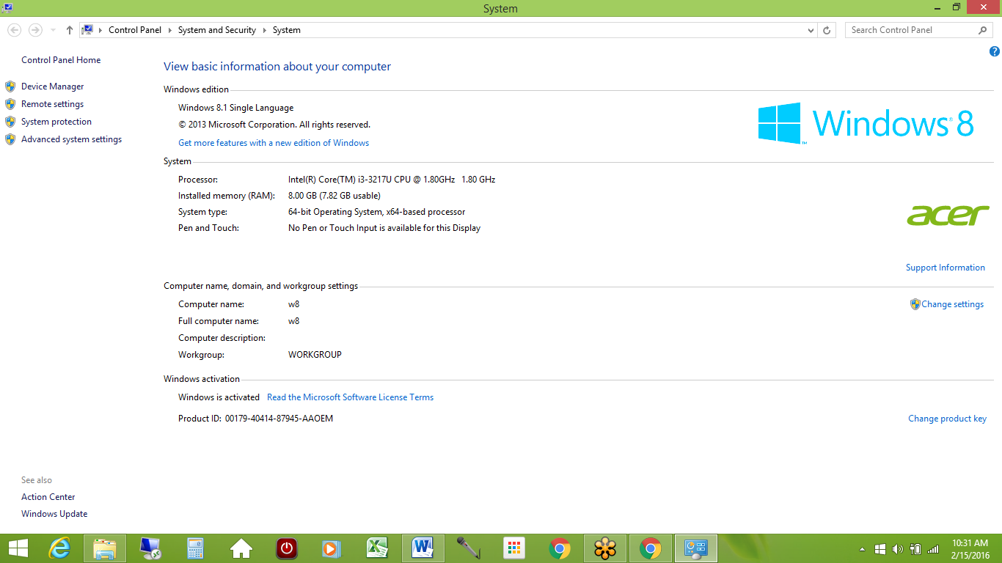

Once vmbox is downloaded,double click on icon ‘**oracle vm box** ‘icon on your desktop. It will show like as in below screen.

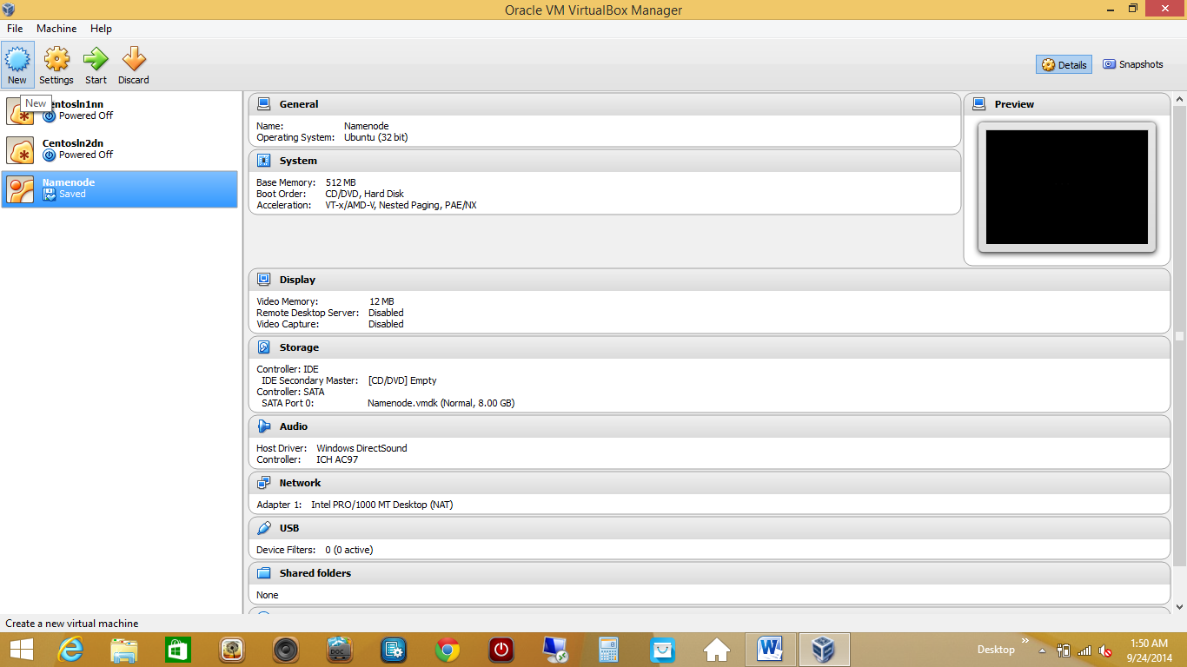

The above screen shows, 3 machines on the left. These are three diff machines that I have added in VMBOX. These machines have centos and Ubuntu OS installed.

To add a new machine, click on NEW as shown above.

That brings up

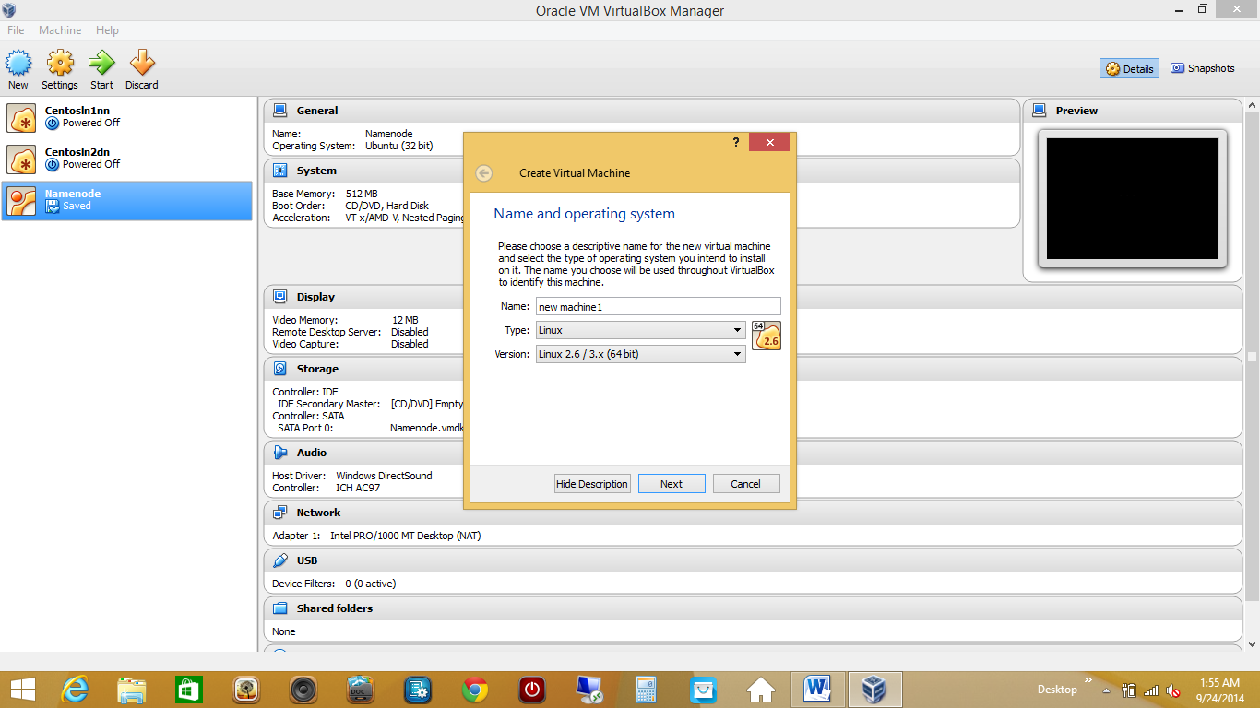

Give a name to your machine, choose type as linux and VERSION-LINUX 2.6/3.X(64 BIT) as my machine is 64 bit. If you are using 32 bit machine, choose linux with 32 bit option.

Click on next

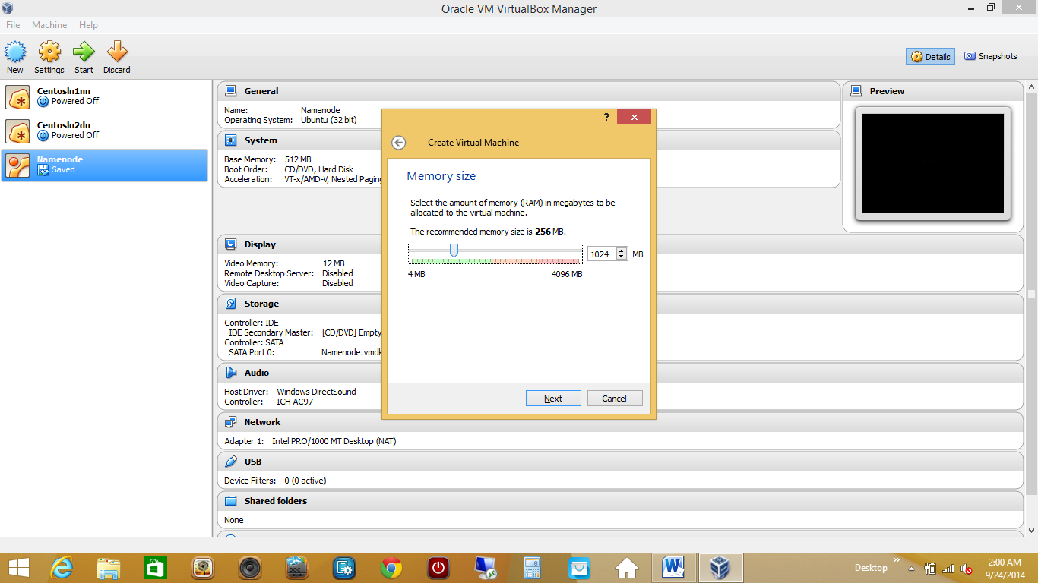

Choose memory size depending on your systems RAM. 256 mb or 512 mb is also fine, however I am choosing 1 gb.

Click on next

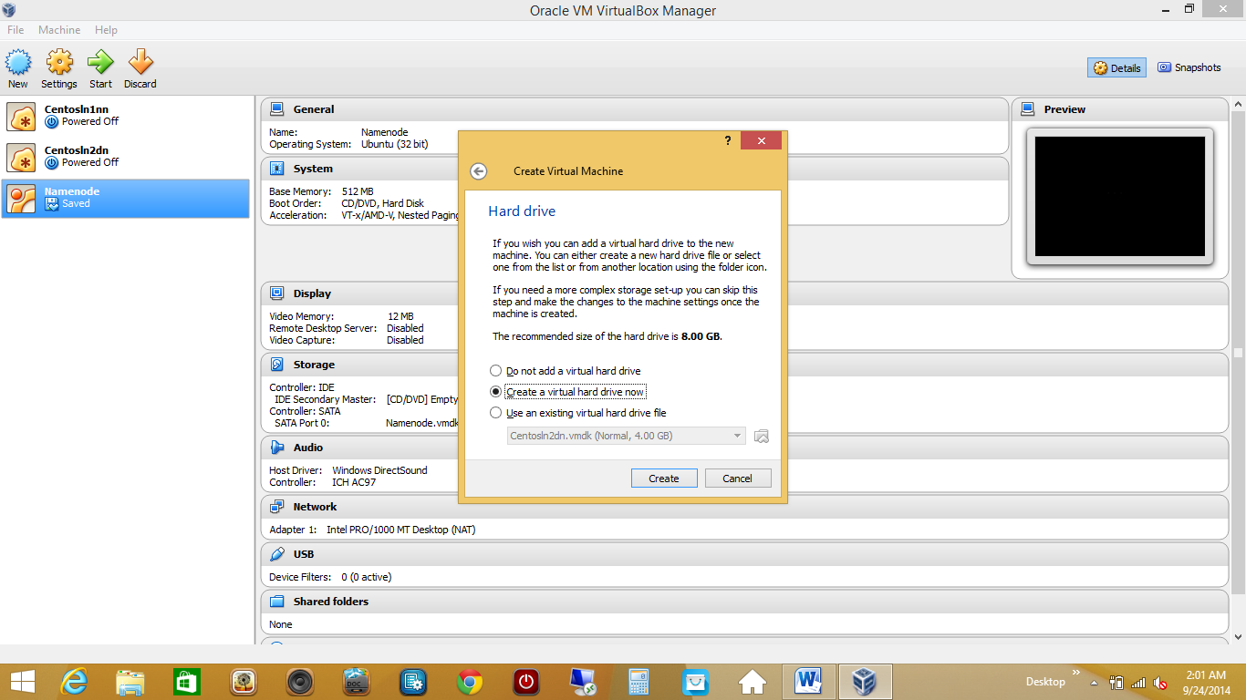

Select –create a virtual hard drive now

Click create

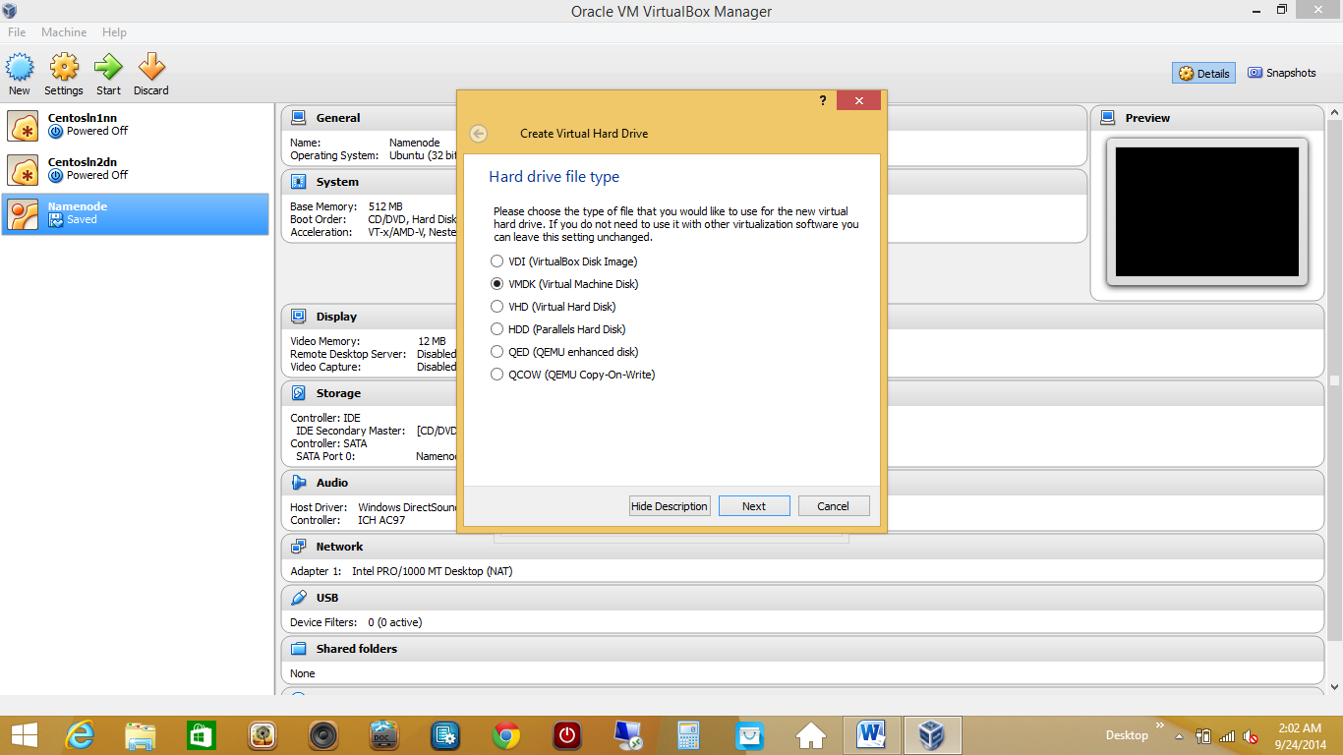

Choose VMDK, so that we can use this virtual machine disk in any other software or on any other machine.

Click next

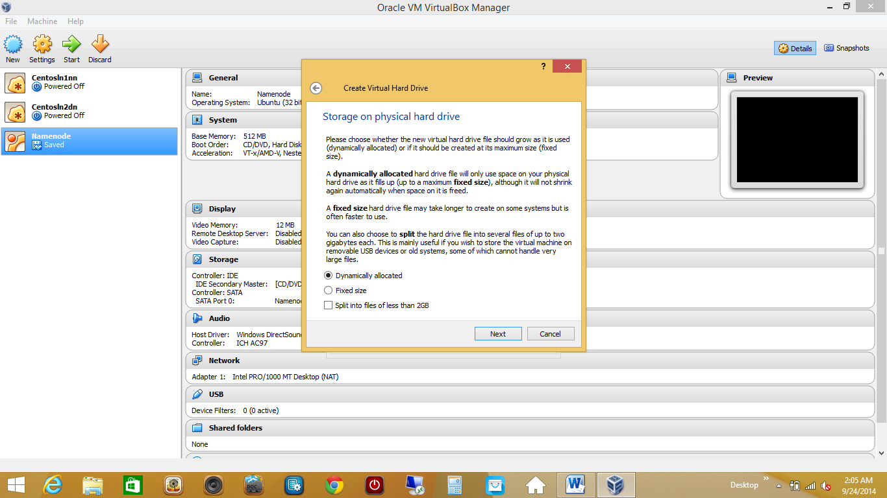

Choose dynamically allocated. Description as explained.

Click next

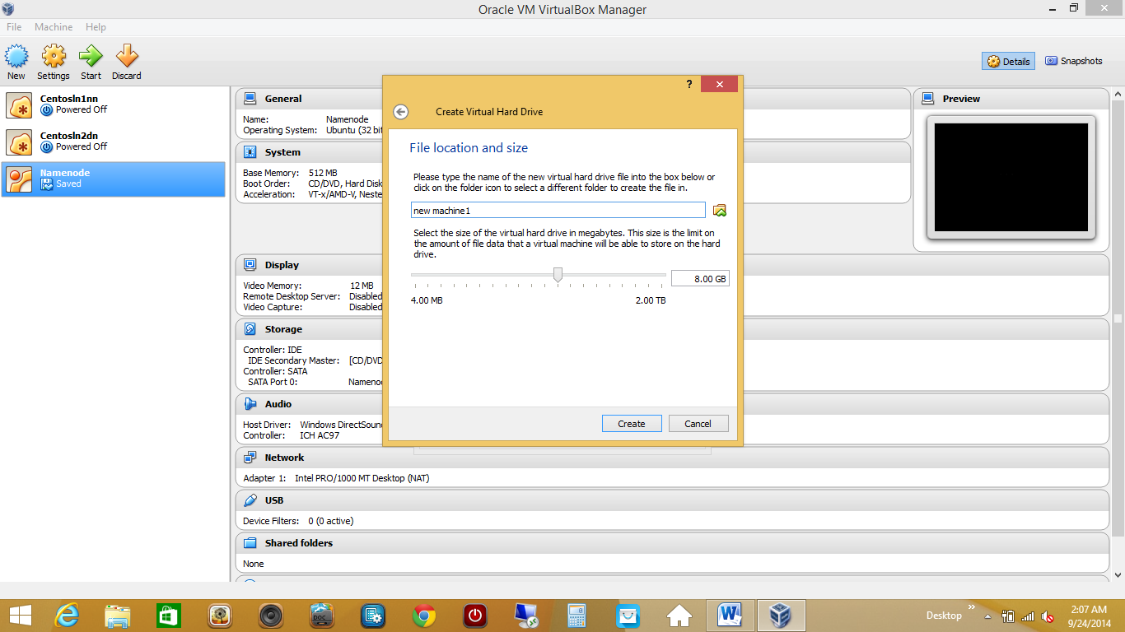

Click on create.

This created a new machine1 in our VMBOX.

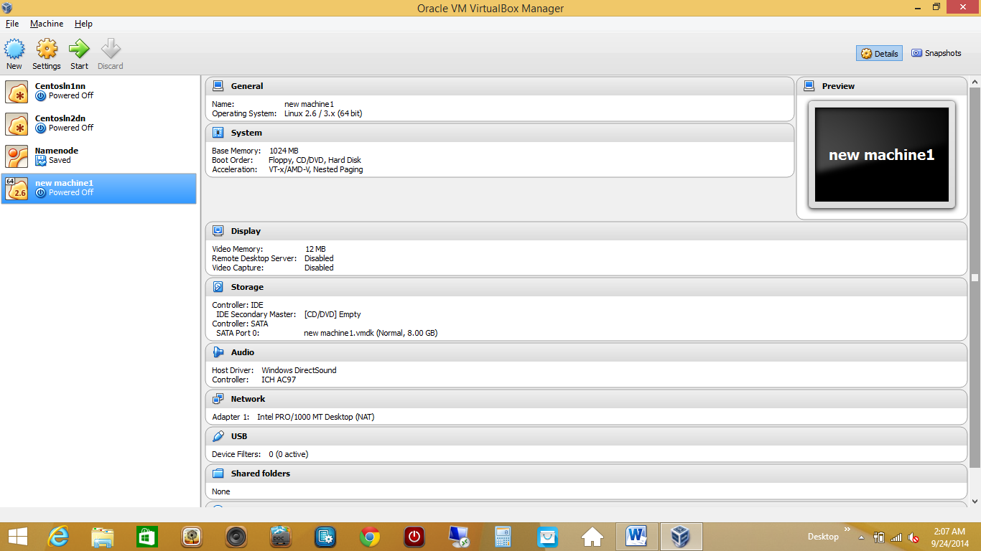

Now this machine is empty and has no OS installed. So we need to install Linux OS in this.

While our new machine is highlighted, click on settings

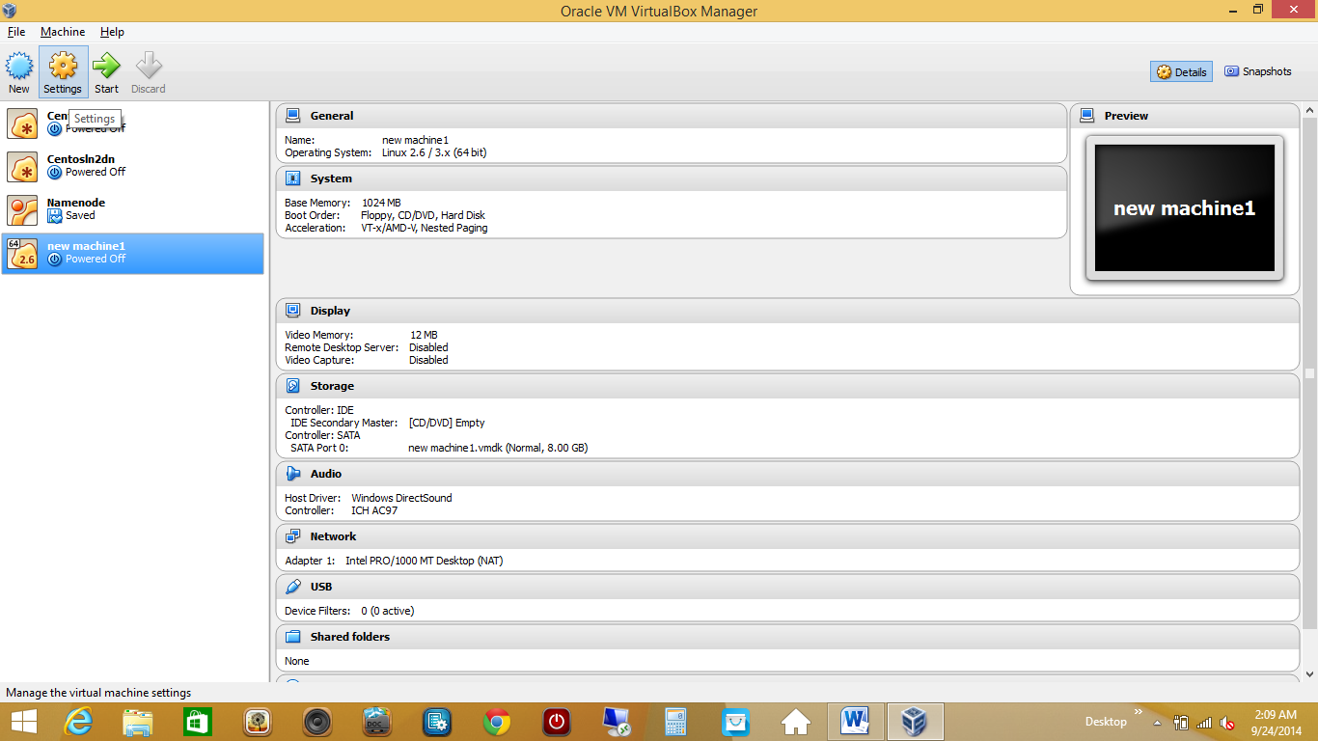

This brings up settings

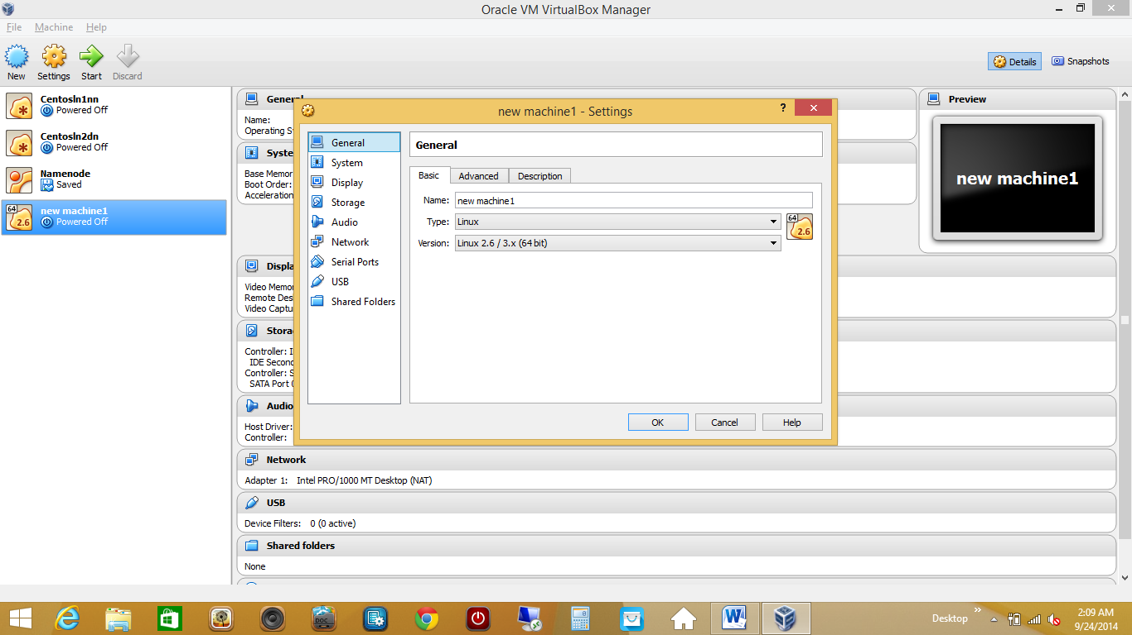

Here select ‘system’ from left side options

Under motherboard tab, uncheck floppy from Boot order box.

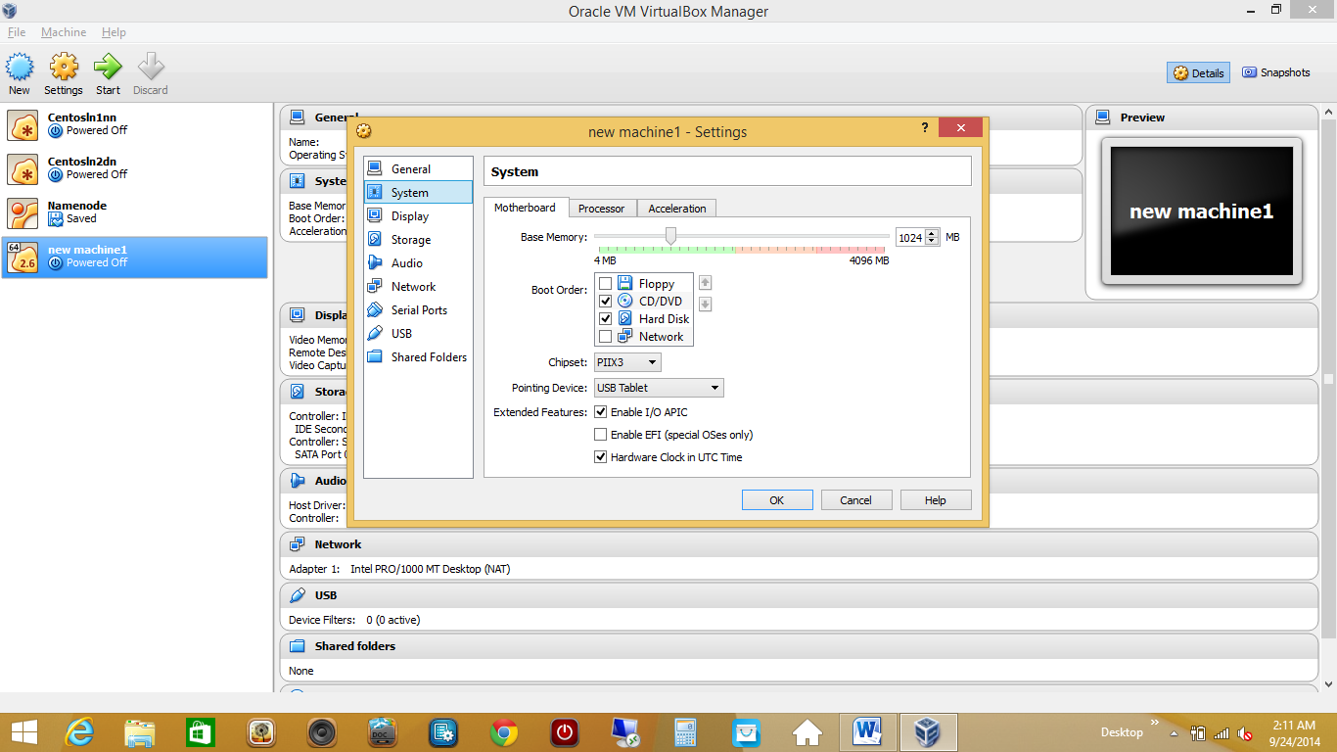

Rest leave things unchanged and click on storage option from left side options.

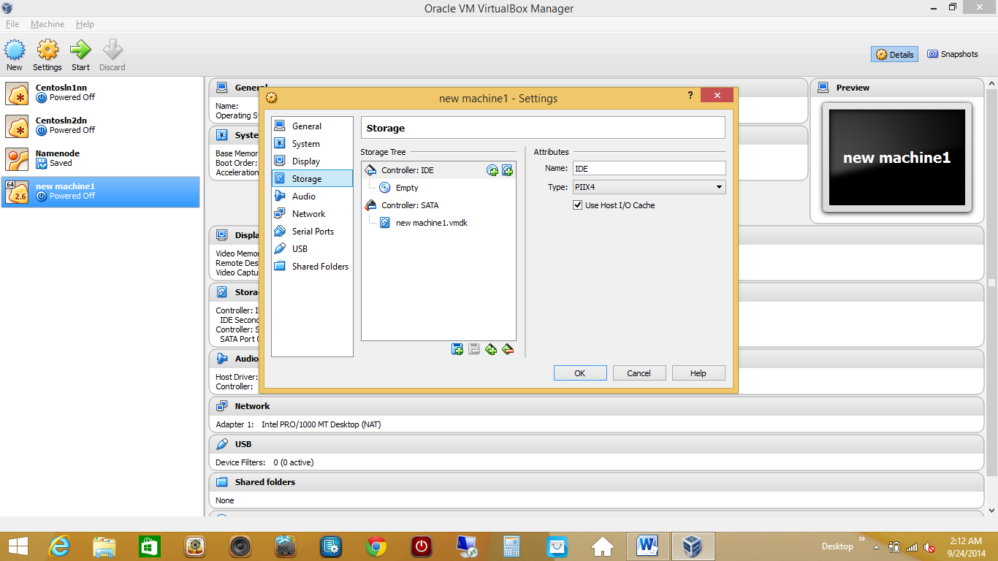

This is the place we need to add a disc image of linux to install linux in this machine.

So we need to download LINUX DISC IMAGE (iso file) from internet.we can download Ubuntu/Centos/red hat linux or any other distribution of our choice.

For centos use this link

<https://wiki.centos.org/Download>

Here once you click, based on ur machine ie 64 bit (x86_64) or 32 bit (i386), CLICK ON RPMS

,then following folder and chose ISOs and that should take you to mirror for your location, from where you can download linux disc image iso file.

Once you have downloaded, linux disc images would get stored and look like this.

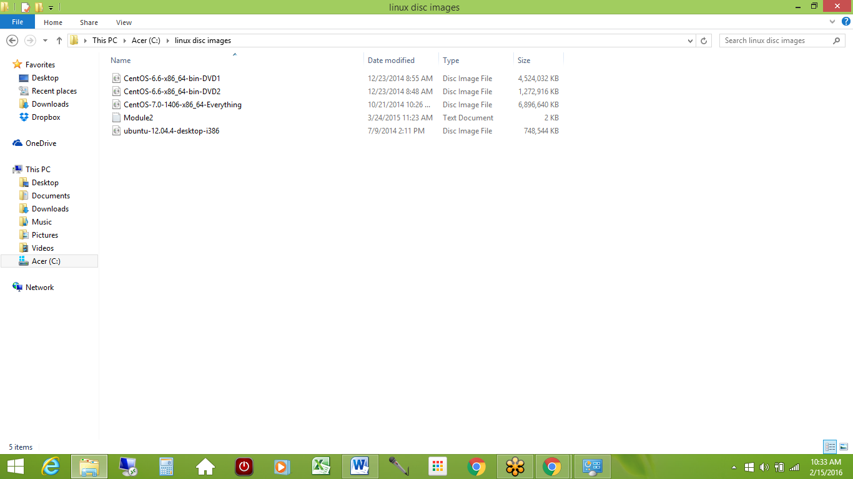

Now coming back to our VMBOX which was at storage option screen

Click on empty

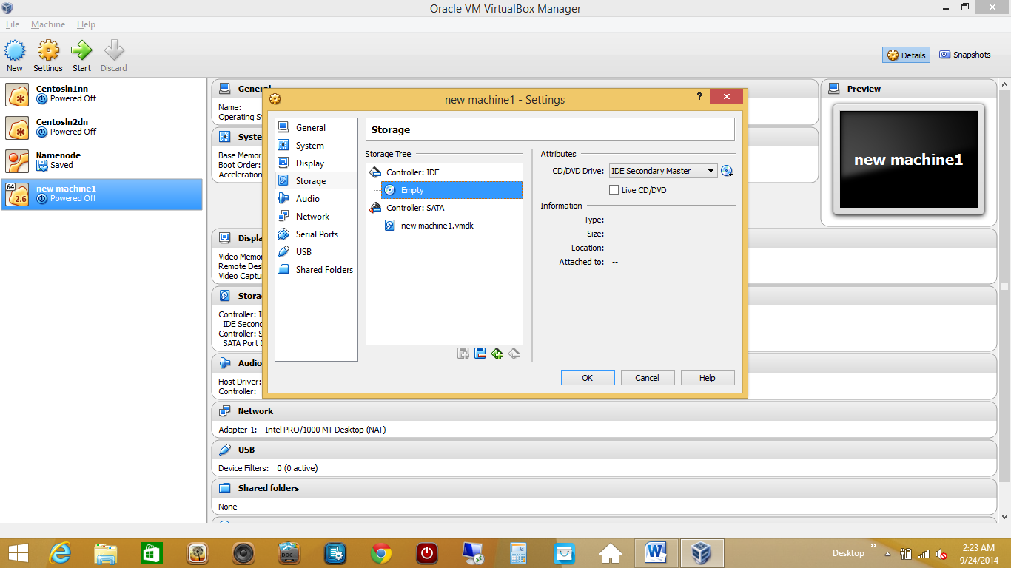

And click on disc on right side below attributes

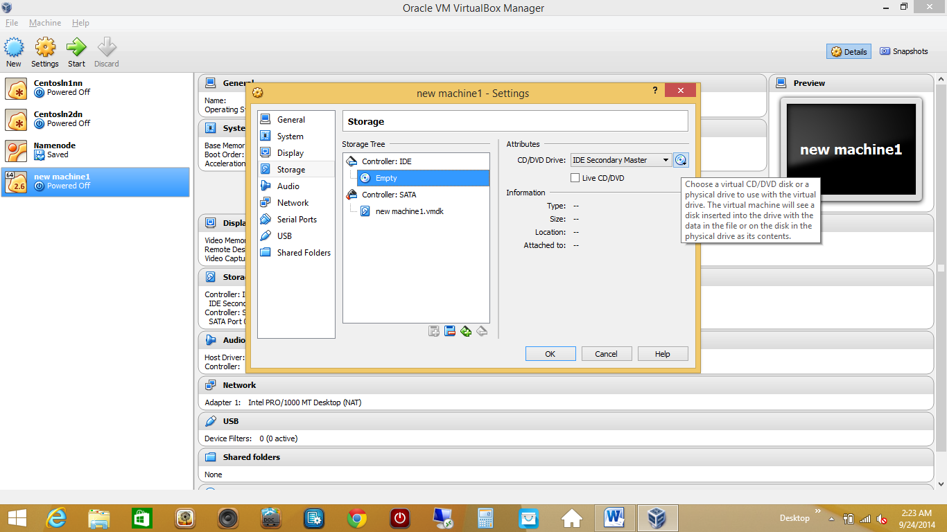

This shows

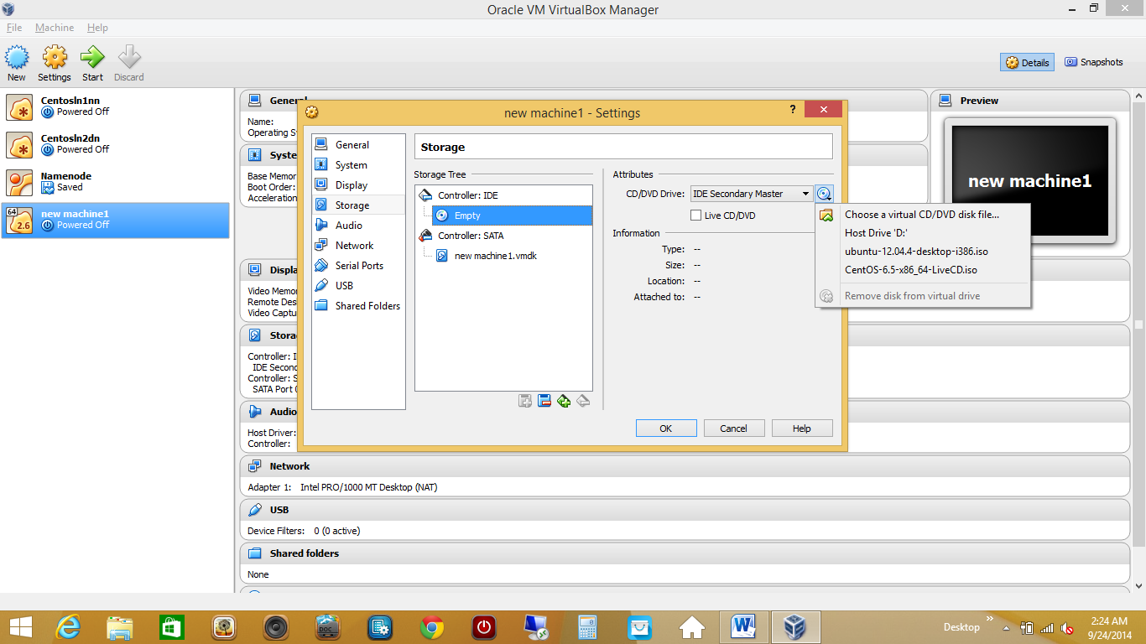

Now click on first option

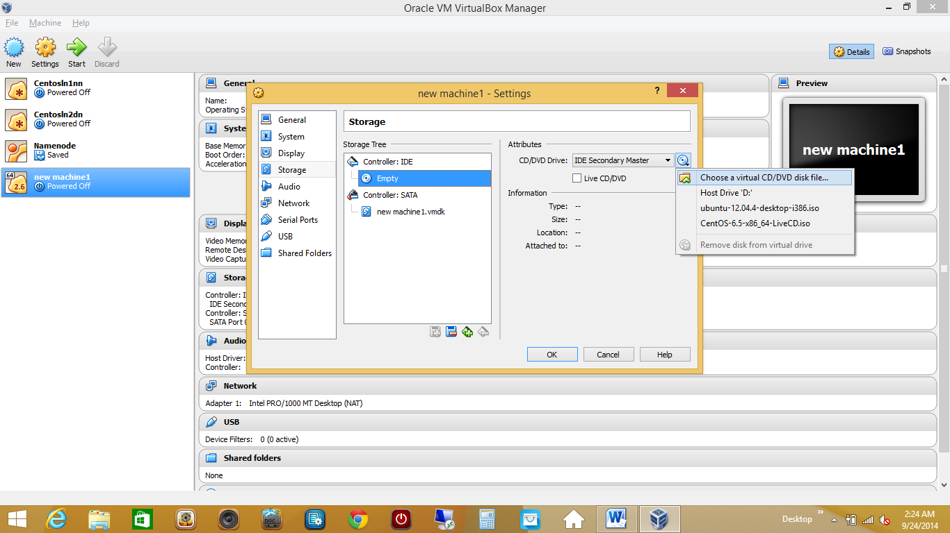

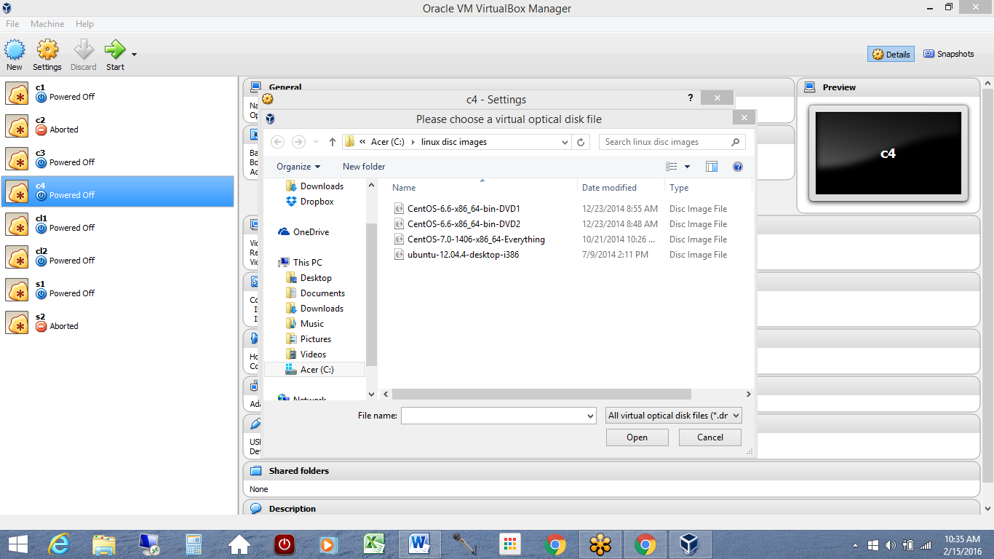

From here I will choose Ubuntu-12.04.4-desktop-i386 and click on open

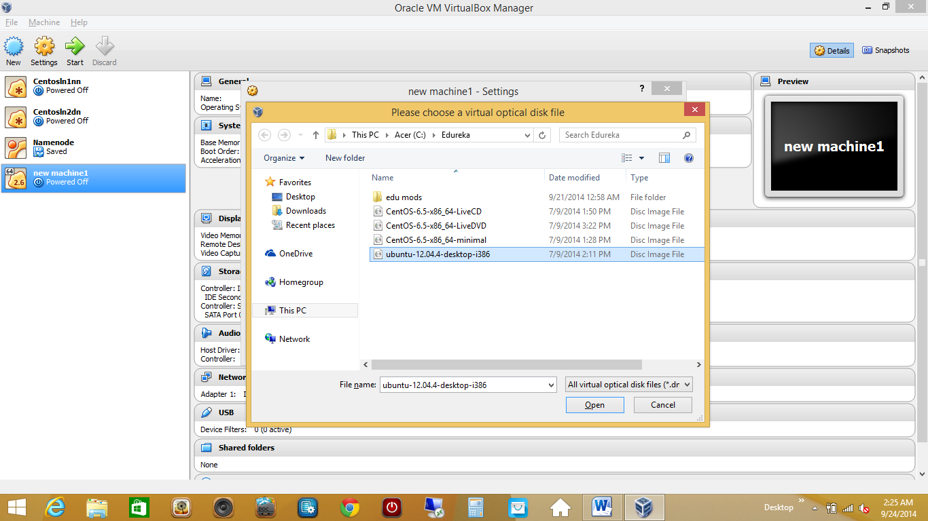

This replaces empty with our disc image name

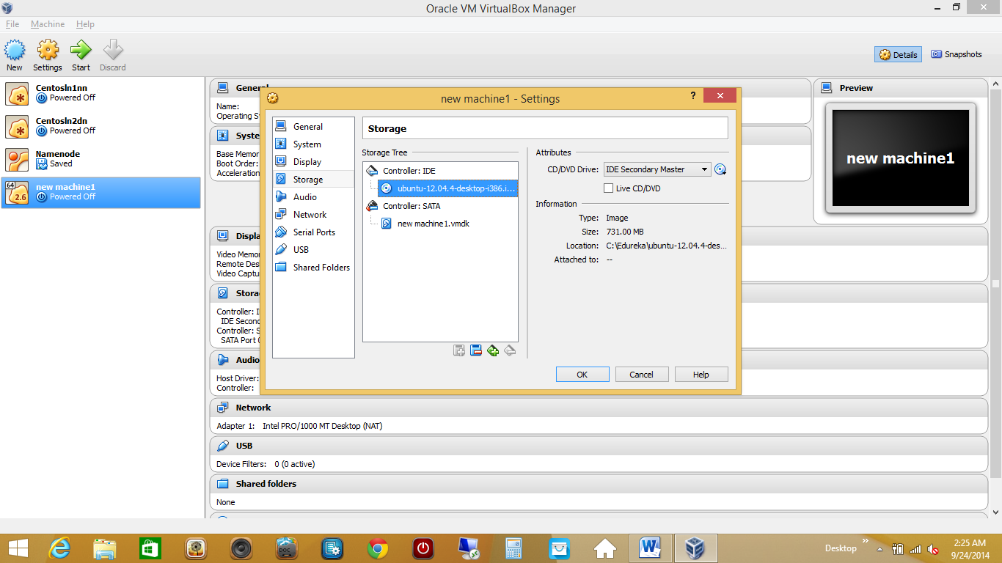

Now select ‘network’ option from left side options

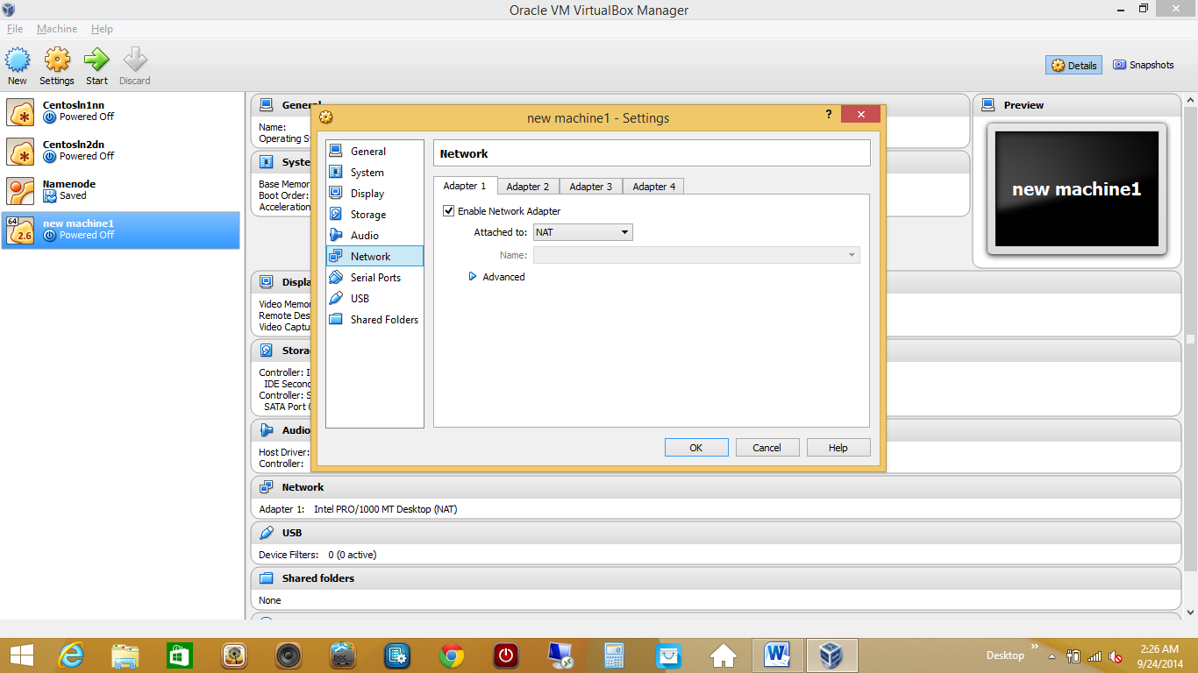

Here we can choose Adapters, Under each adapter tab, we can select one different adapter.

But I am going to use just Adapter 1 for now.

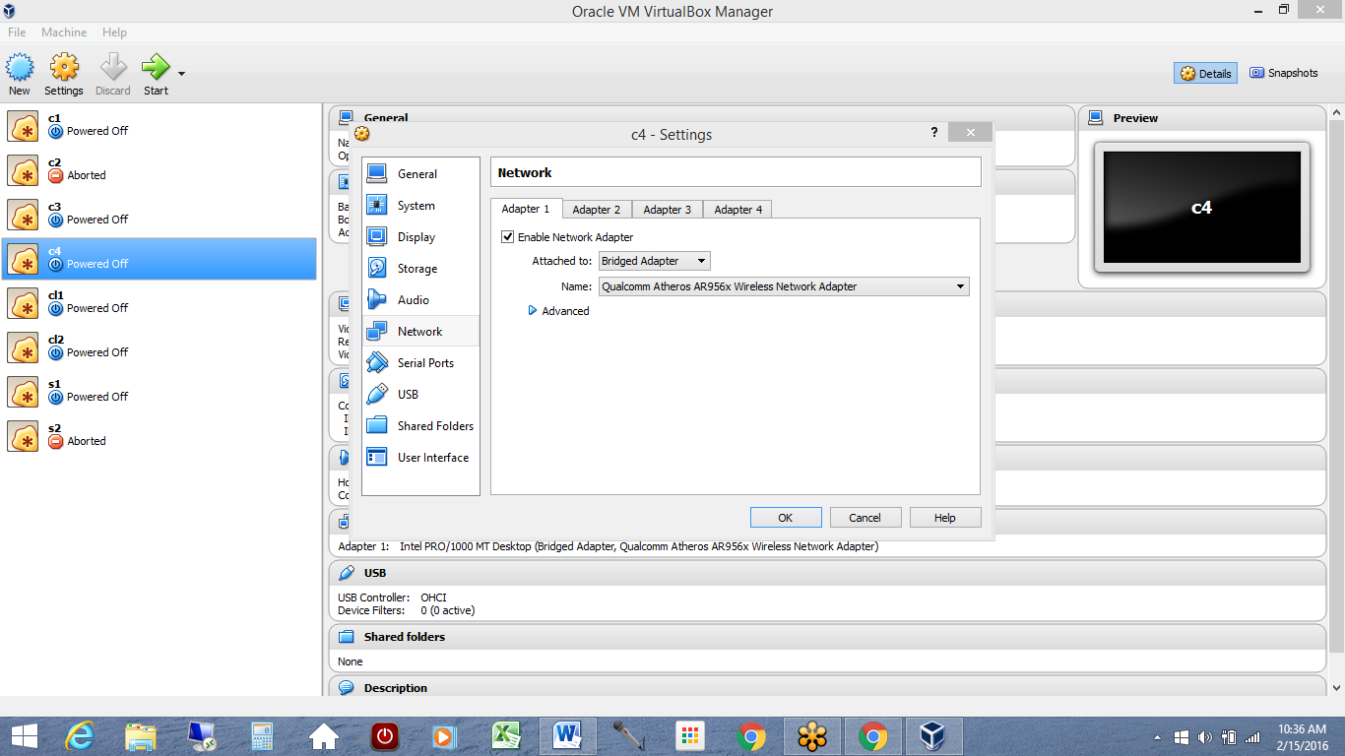

Select Enable network adapter option and choose Bridge Adaptor

This option enables your linux machine within vmbox to have access to internet as your main machine/PC and also allows all machines to talk to each other.

You can read about these adapters from google.

Finally when all this is done,click on ok.

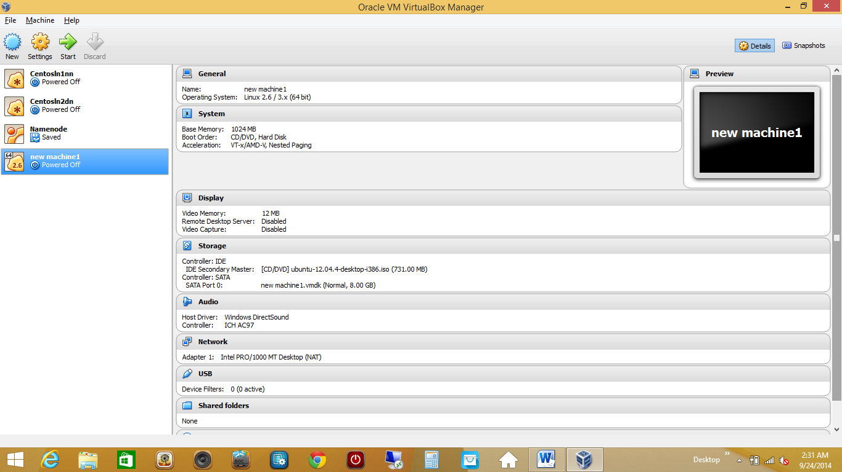

Notice the details on right side of panel.

Now we need to start our machine.

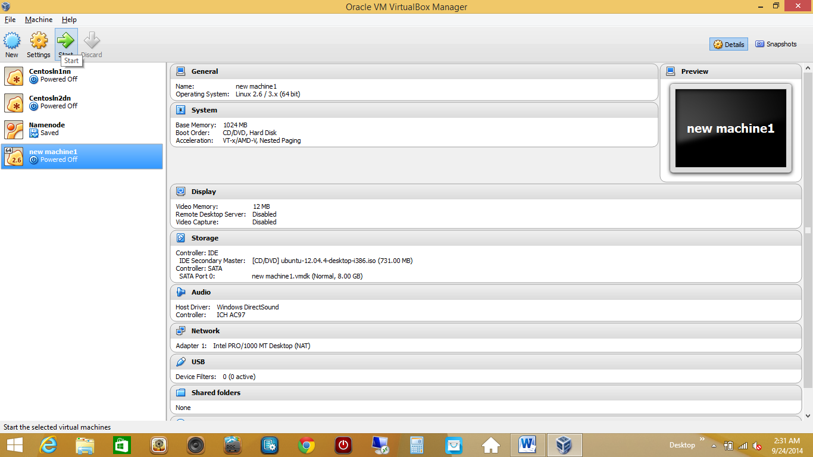

‘CENTOS1’ machine.

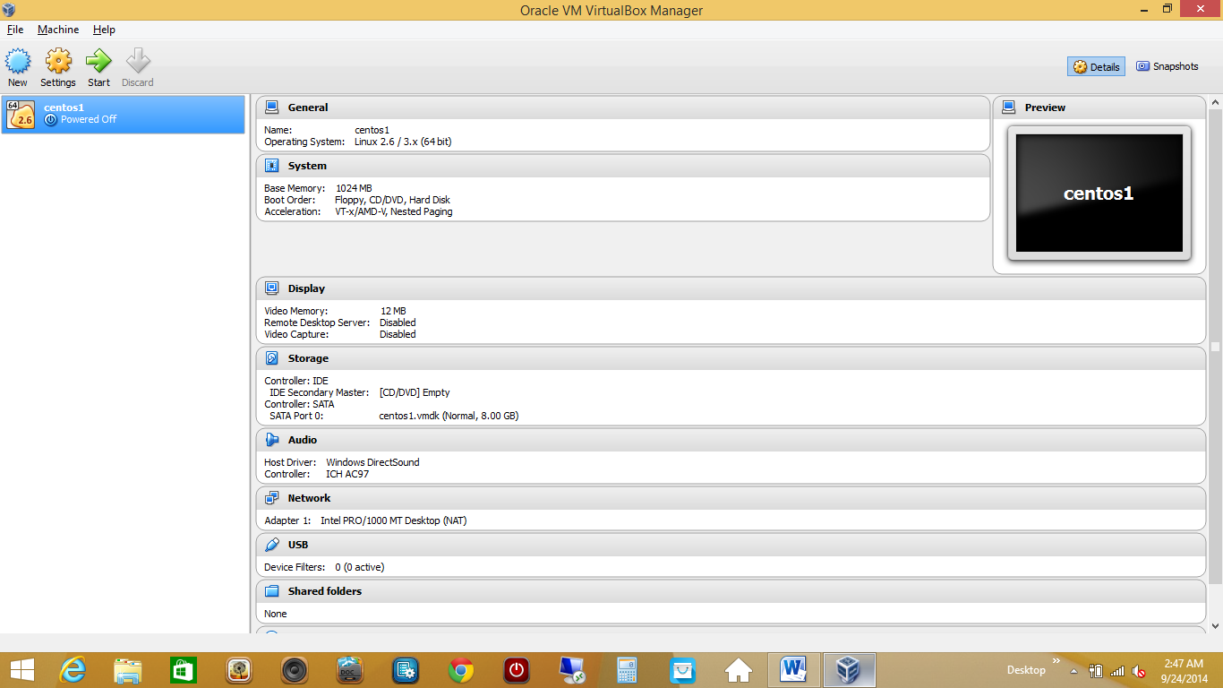

Click on settings with your machine highlighted

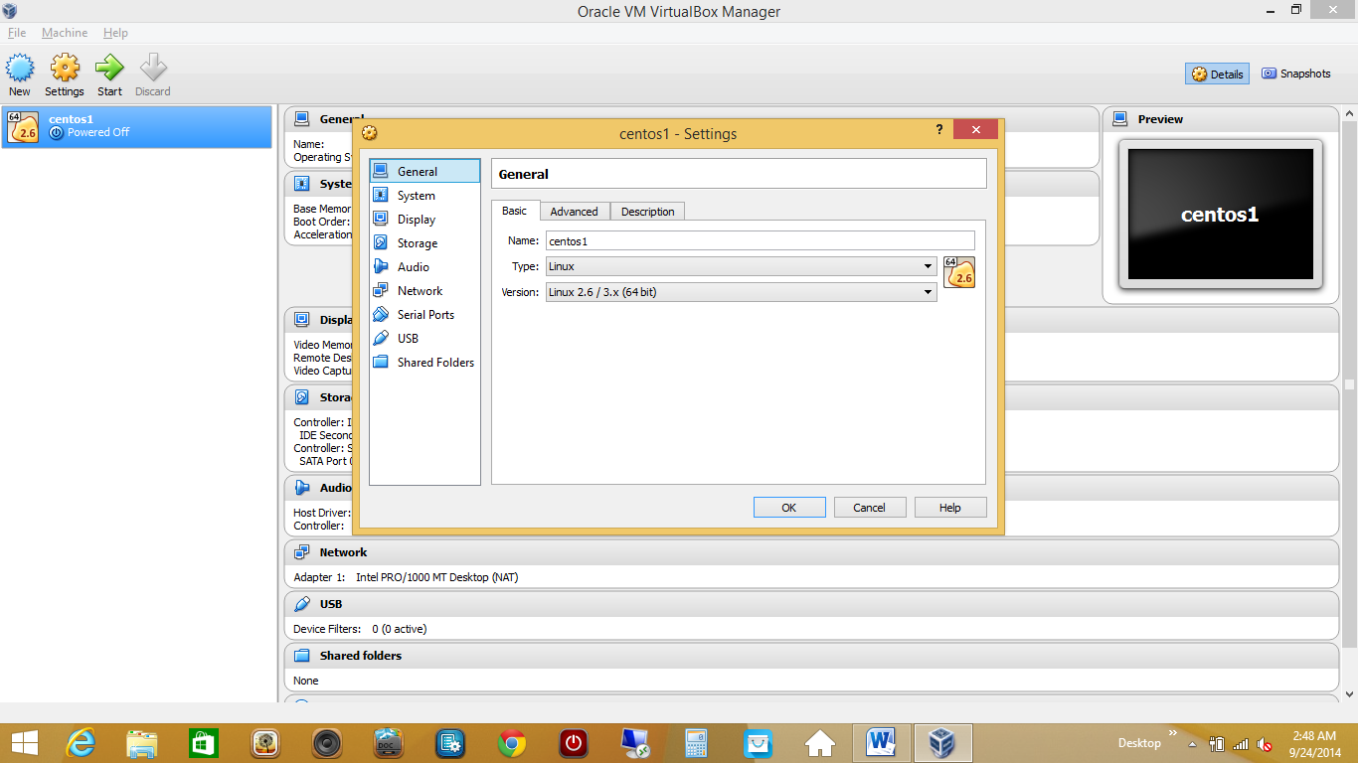

In system>motherboard tab> unselect floppy in boot order

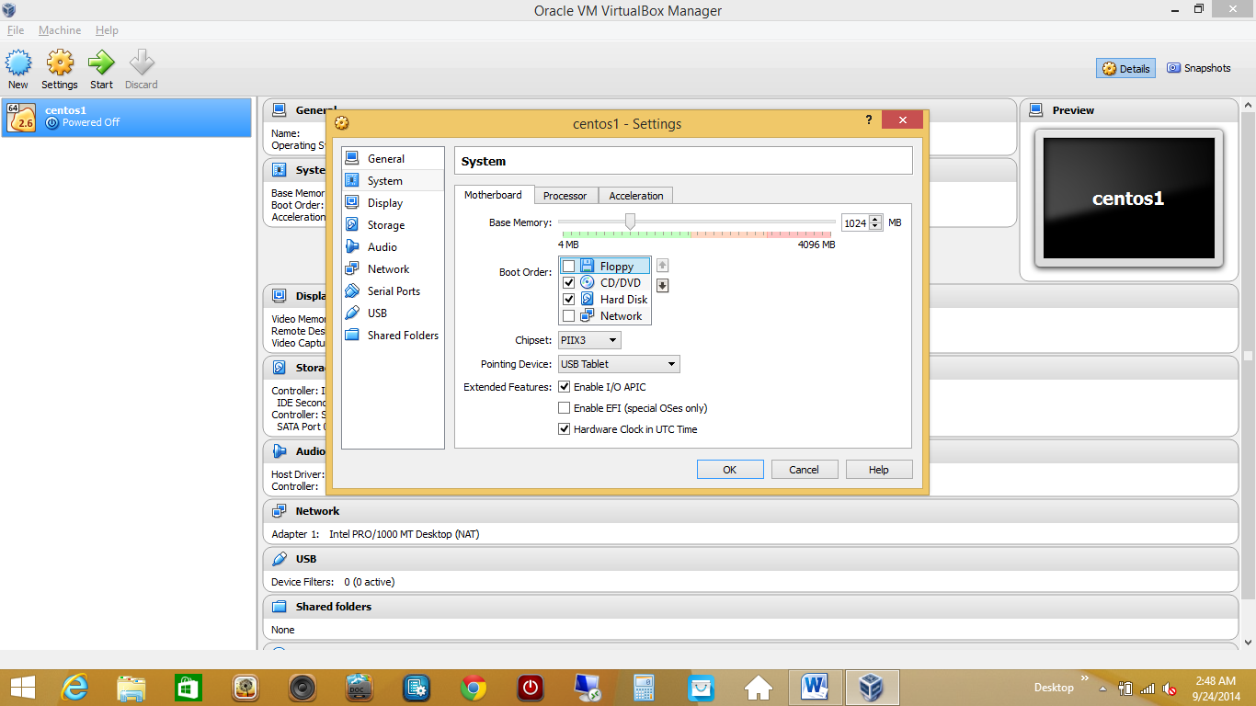

Click on storage option and then click on empty

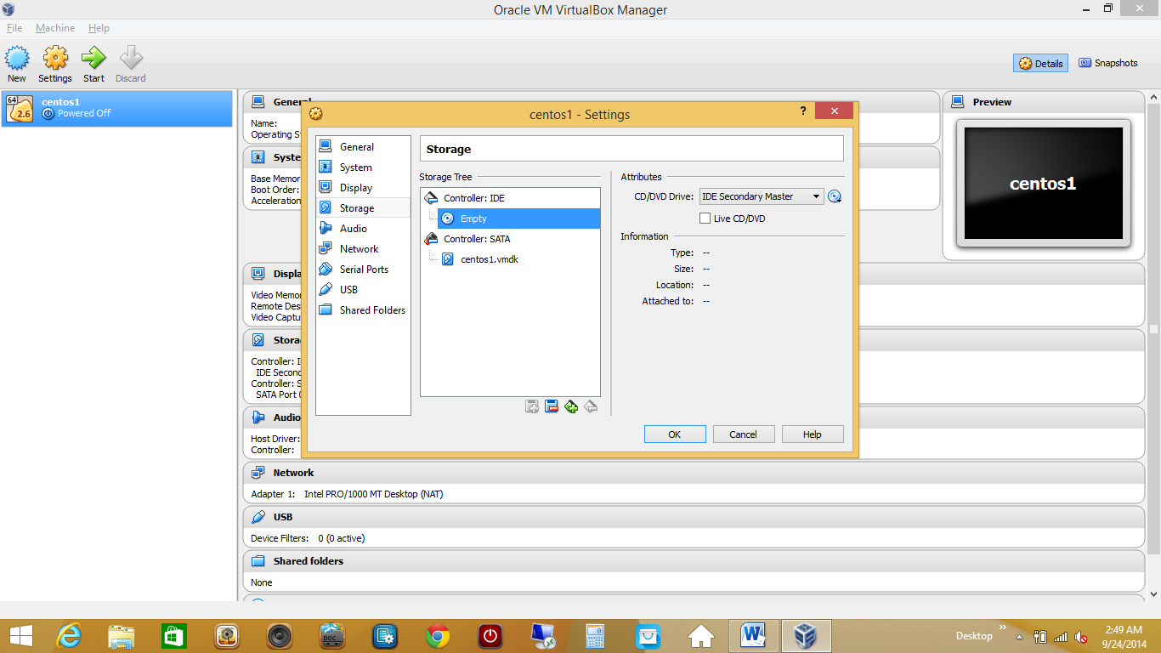

Click on disc icon

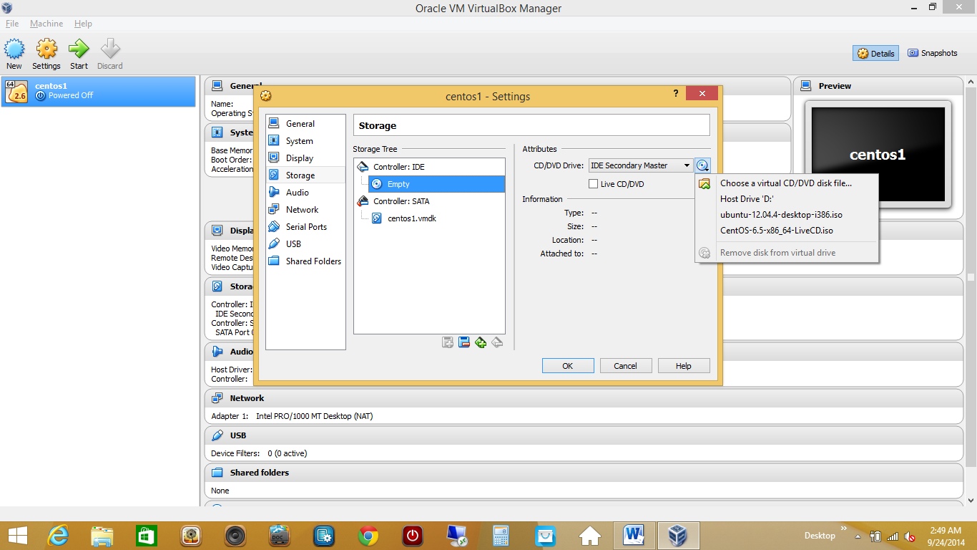

Choose a virtual CD/DVD disc file

And choose a disc image i.e. DVD1



Click on open

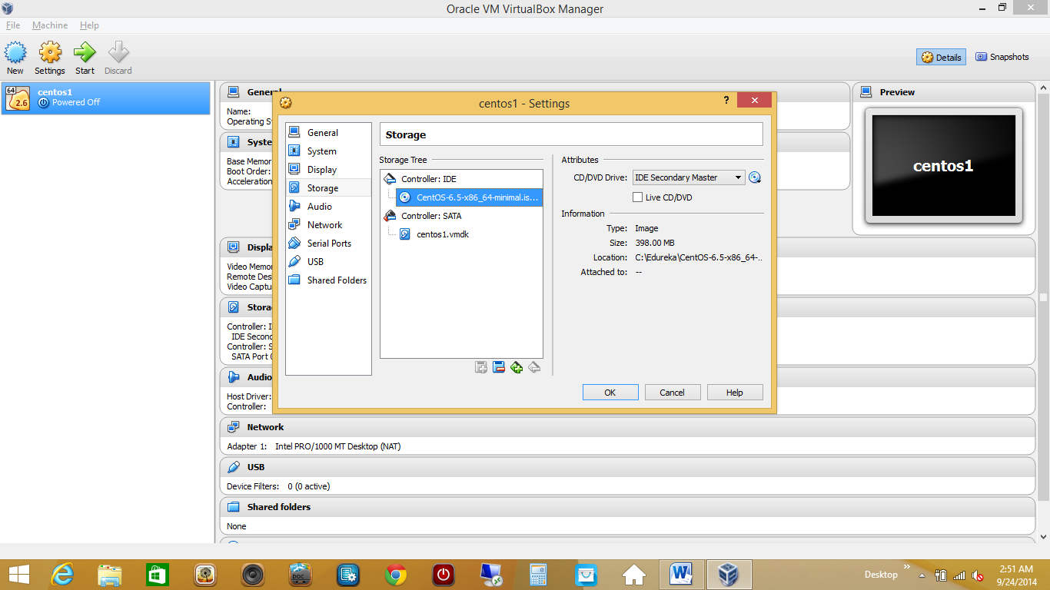

Now choose network option

And choose bridge adaptor

Now click on ok.

Now we need to start our machine.

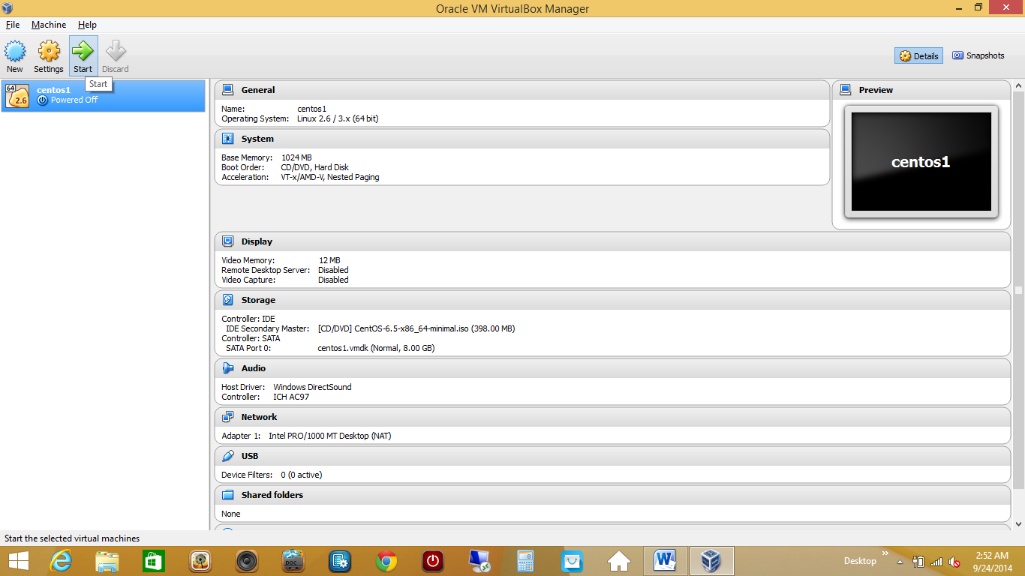

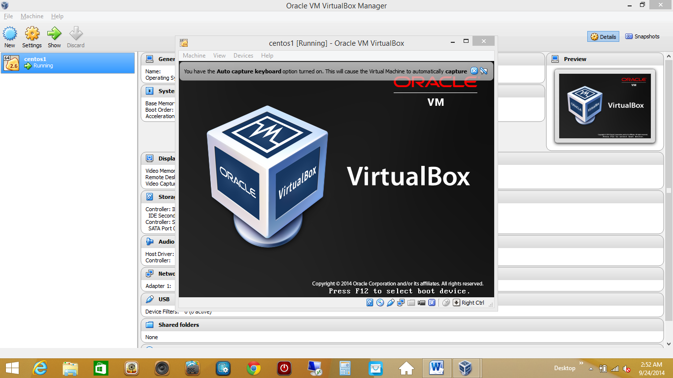

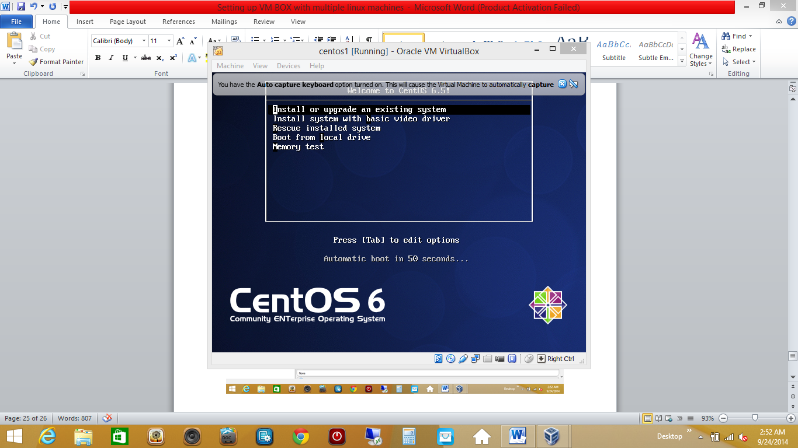

Choose first option

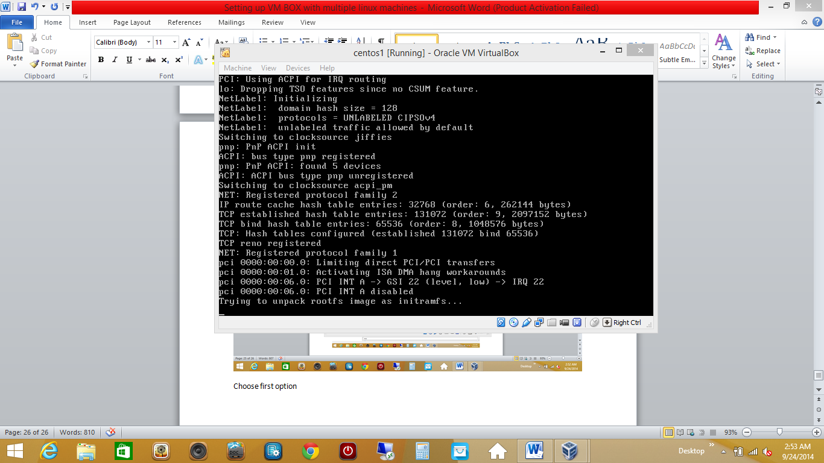

Its unpacking and installing from disc image

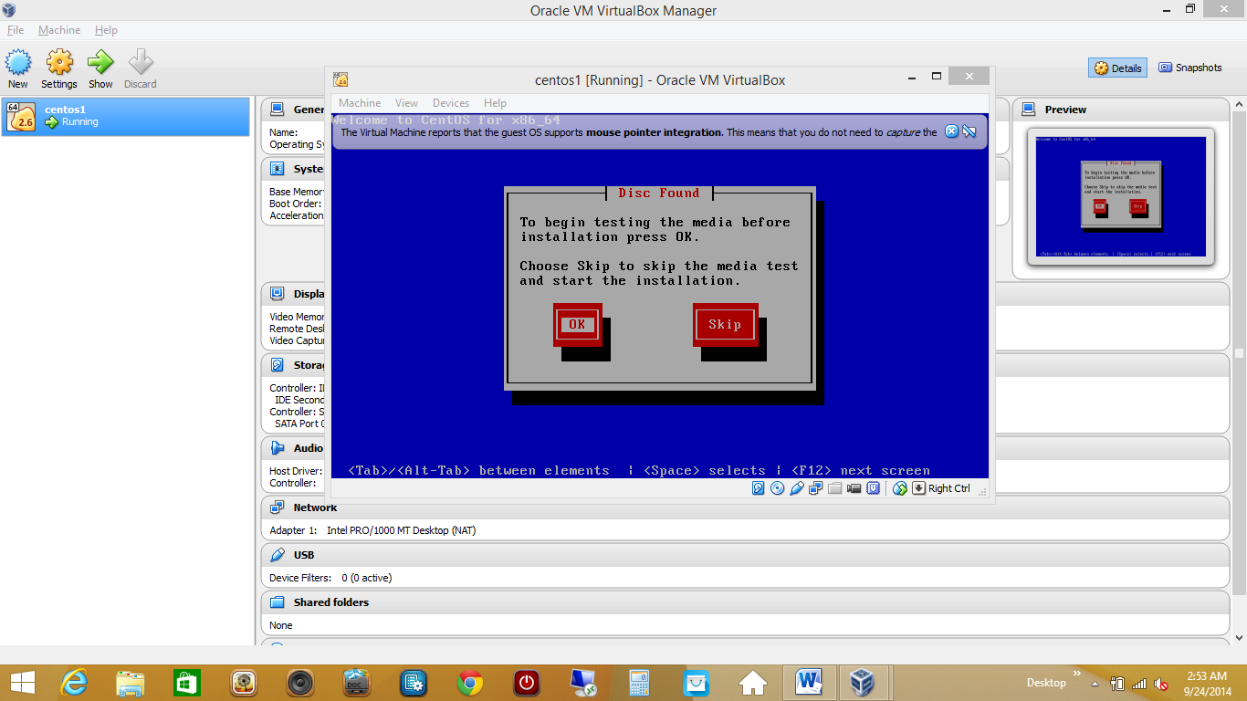

You can do skip here

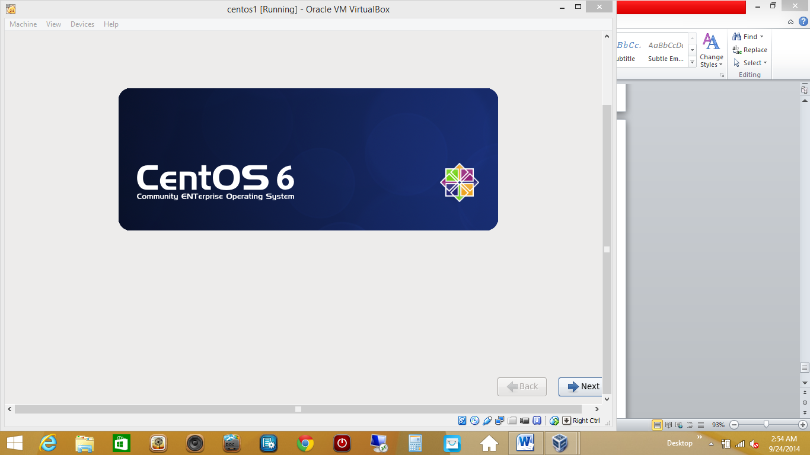

Click next,select English

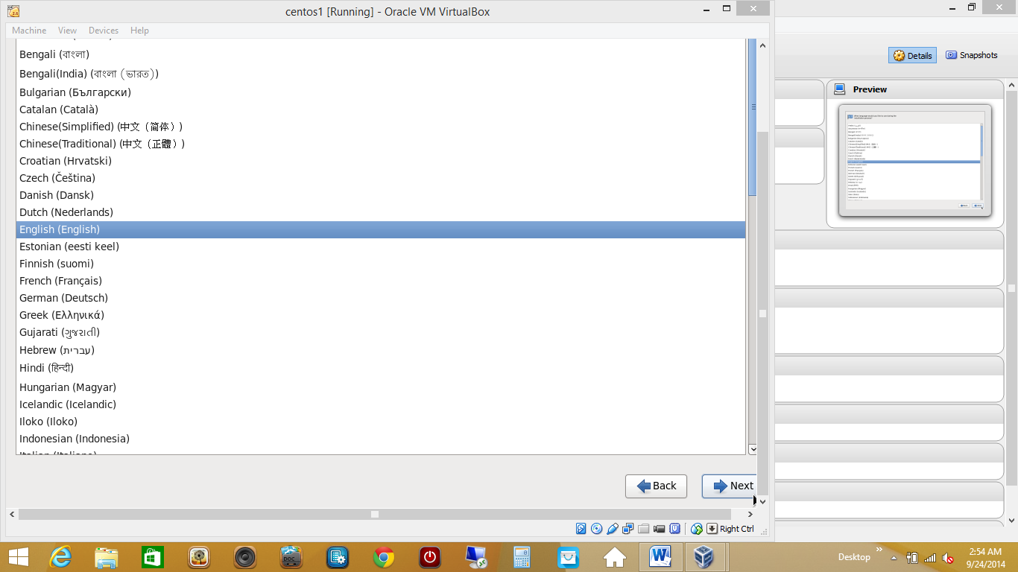

Click next

Select US English for keyboard

Click next

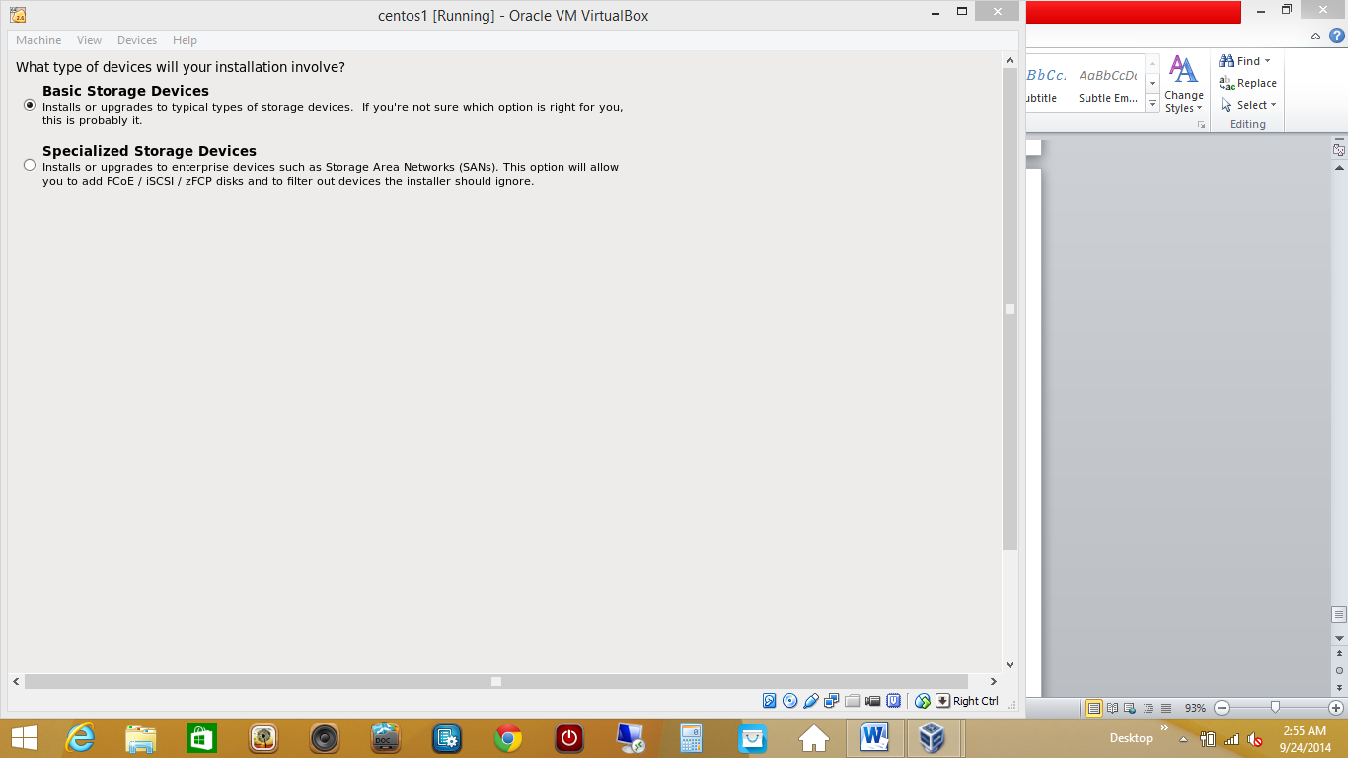

Let basic storage devices be selected

Click on next

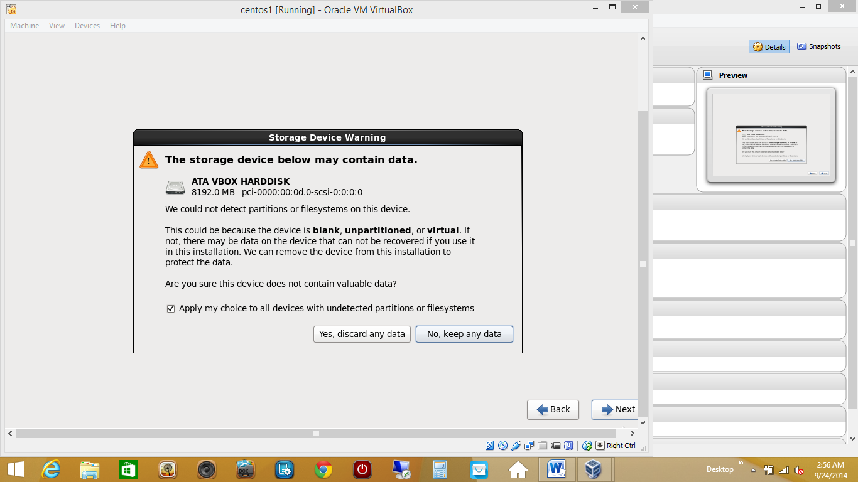

Choose yes, discard any data and click on next

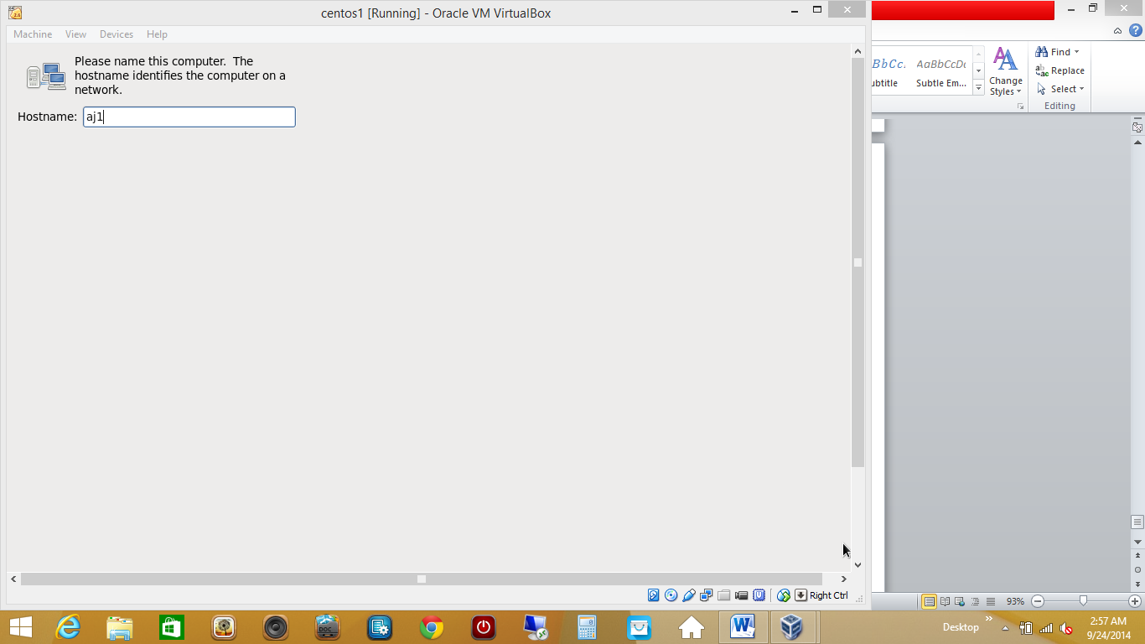

In above screen give a name to your system

And click next

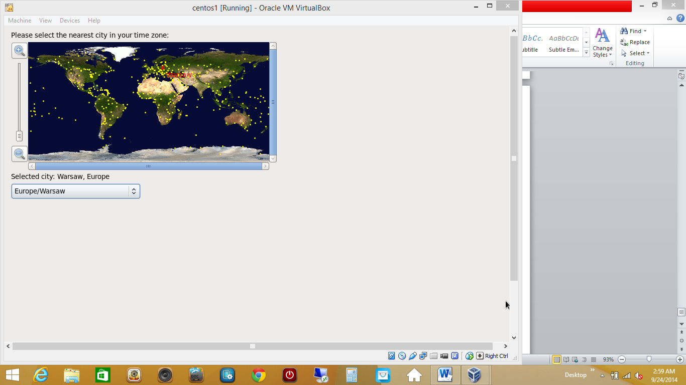

Choose time zone and click next

Click next

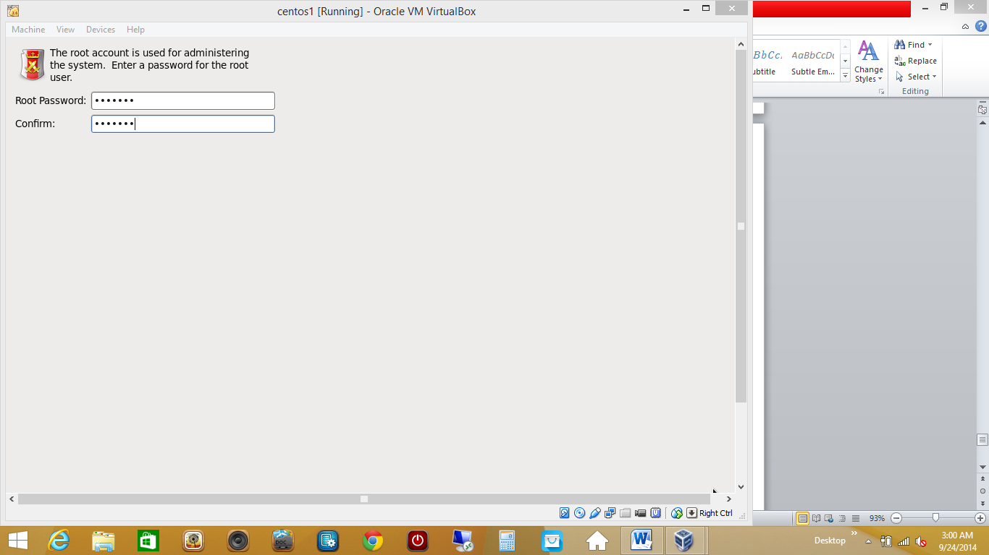

Enter a root password and remember this

Click next

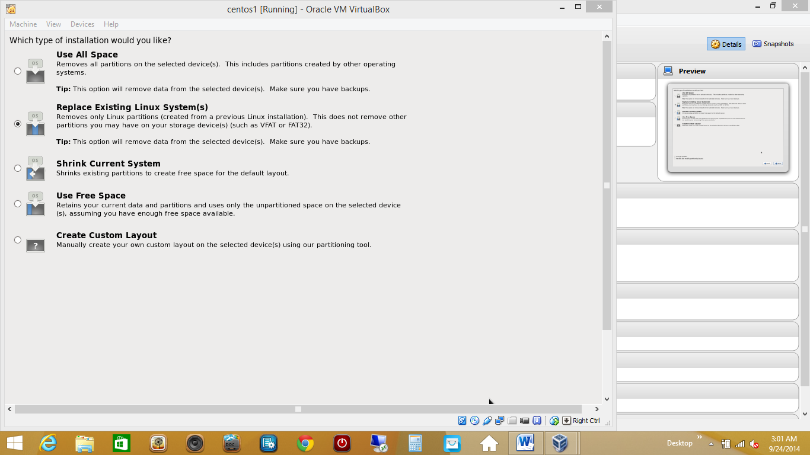

Here let the second option be selected.

Click on next, it shows

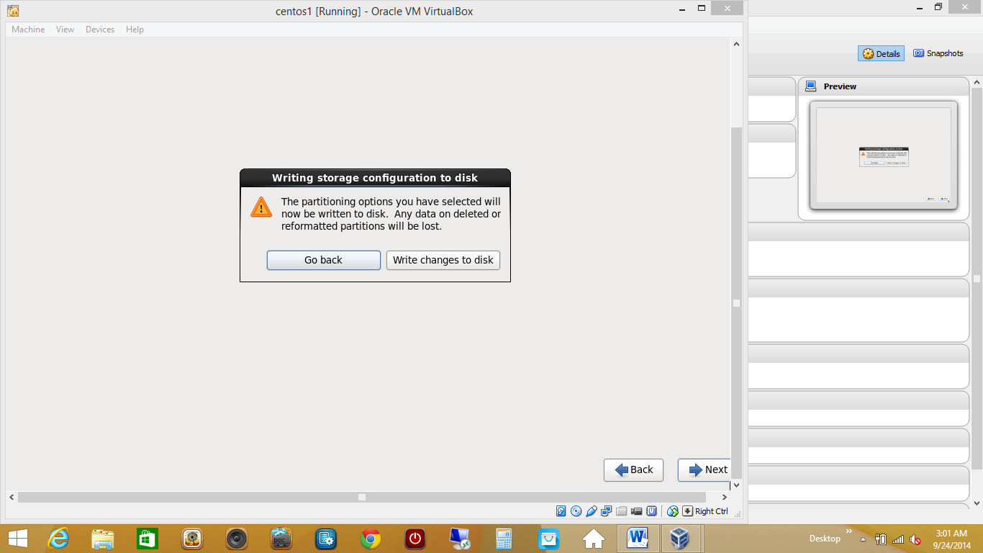

Click on write changes to disk and this will start installation

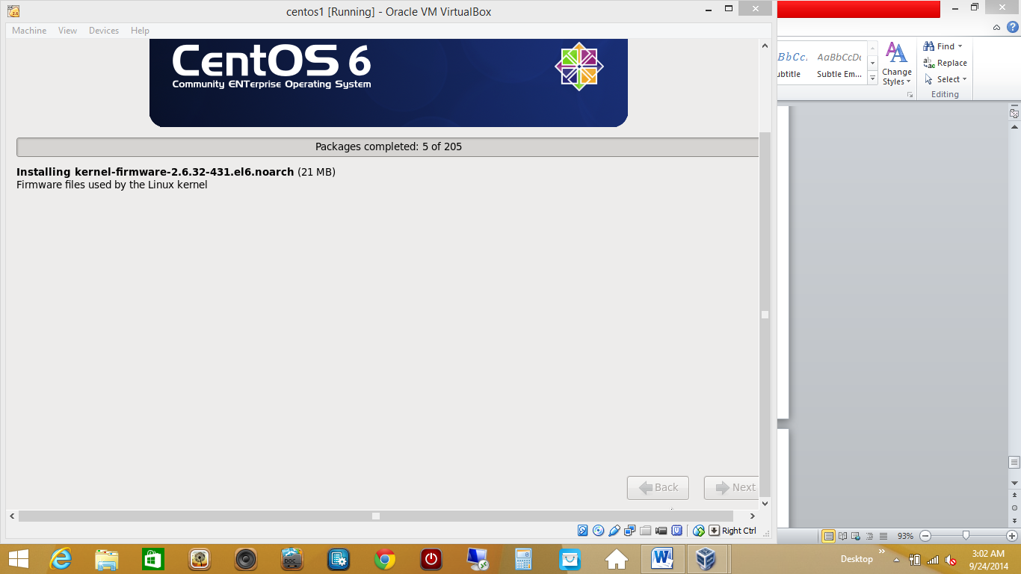

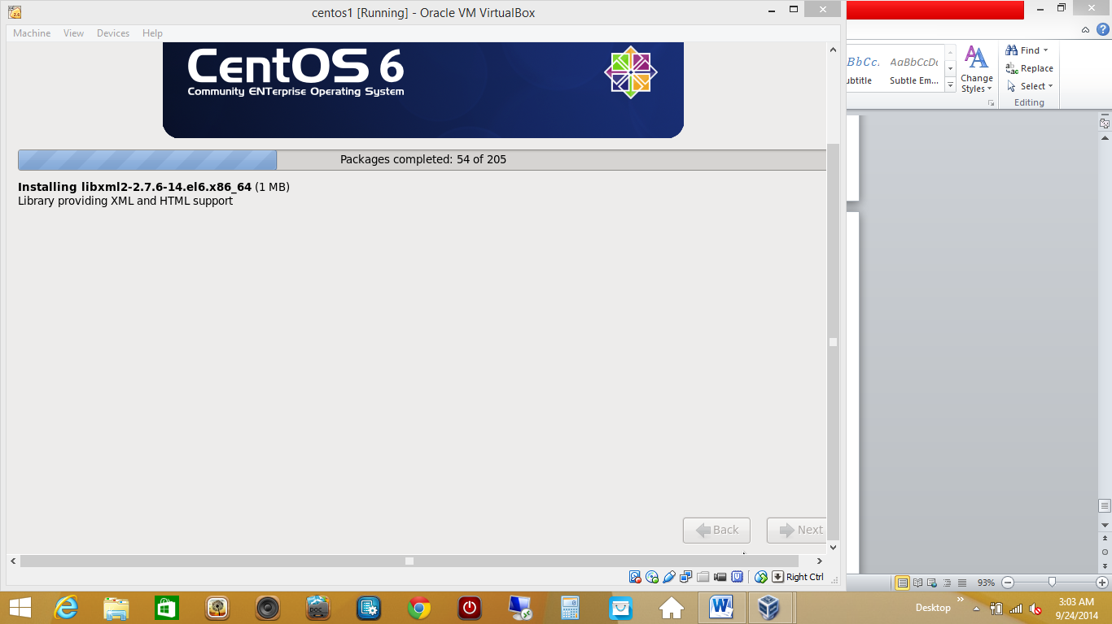

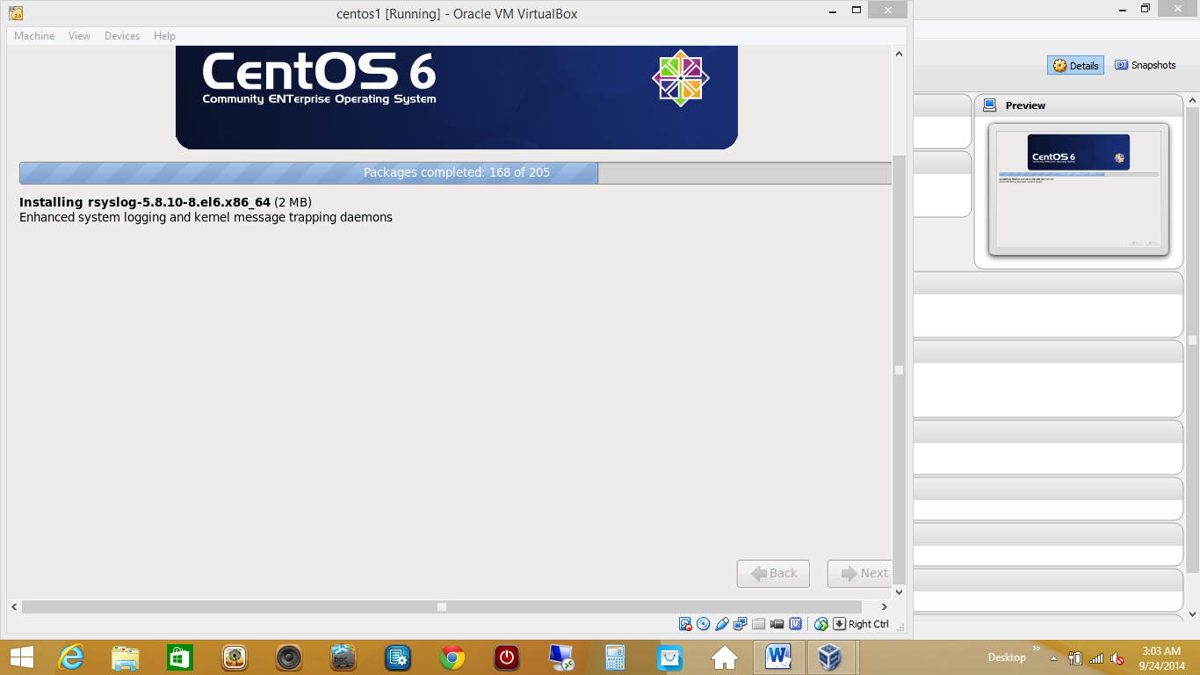

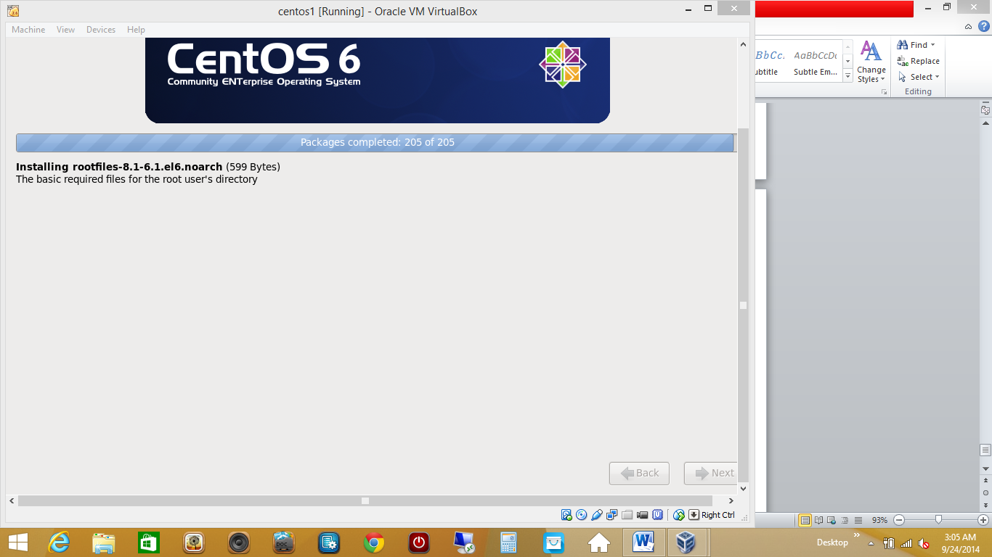

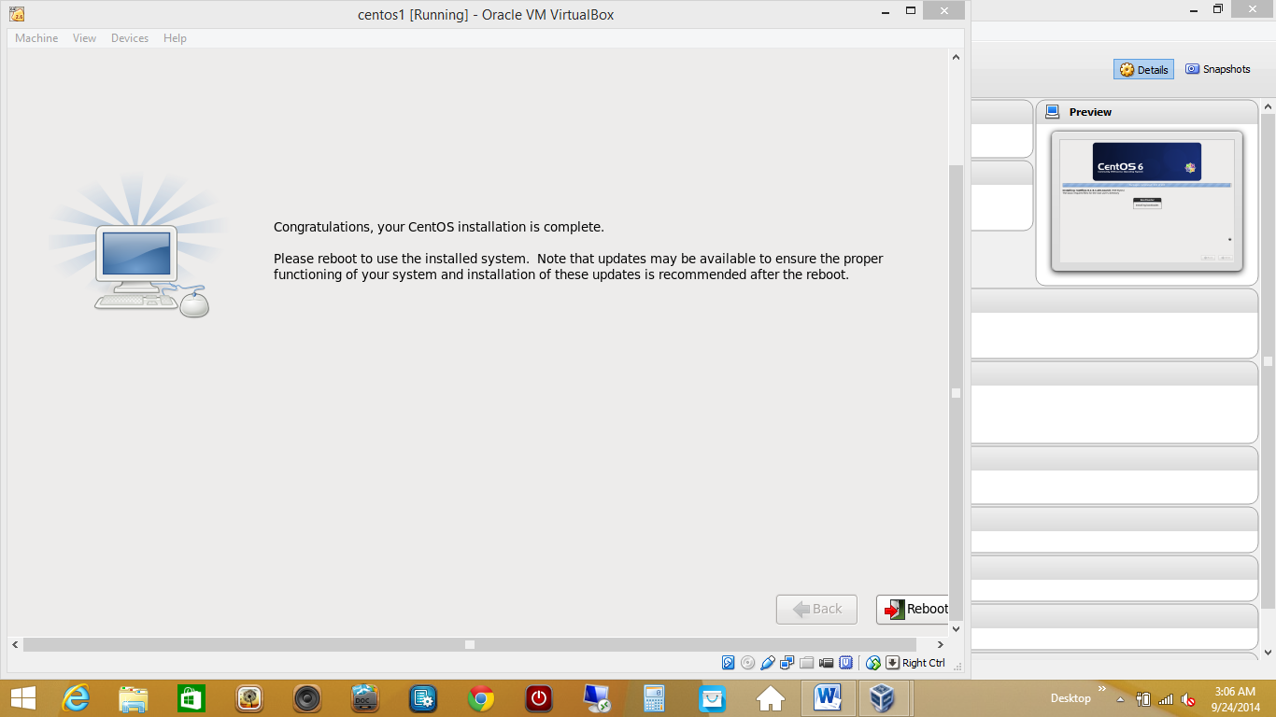

Finally click on reboot

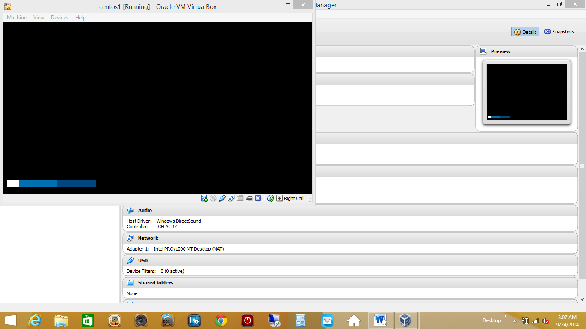

After rebooting,Accept license, click on forward ,give a username and password and chose time and keep hitting next and finally finish.

That’s it.

Your centos machine is set.

Once your machine starts:

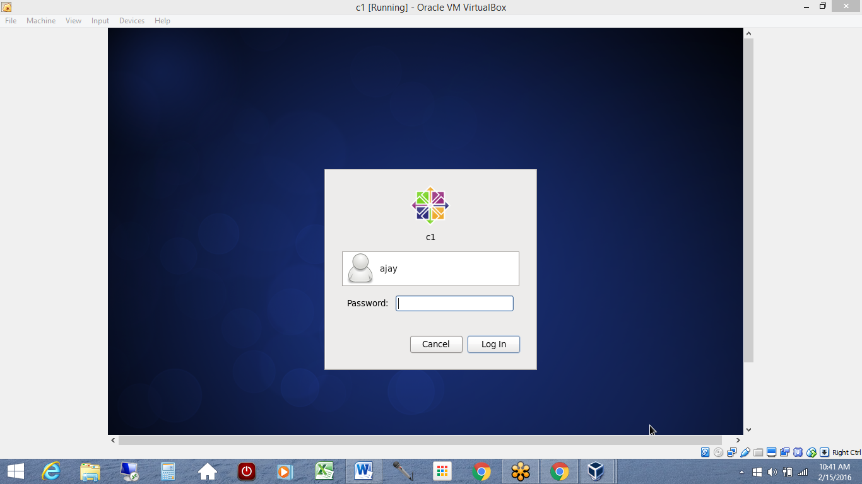

Login and enable internet aby clicking on top right corner

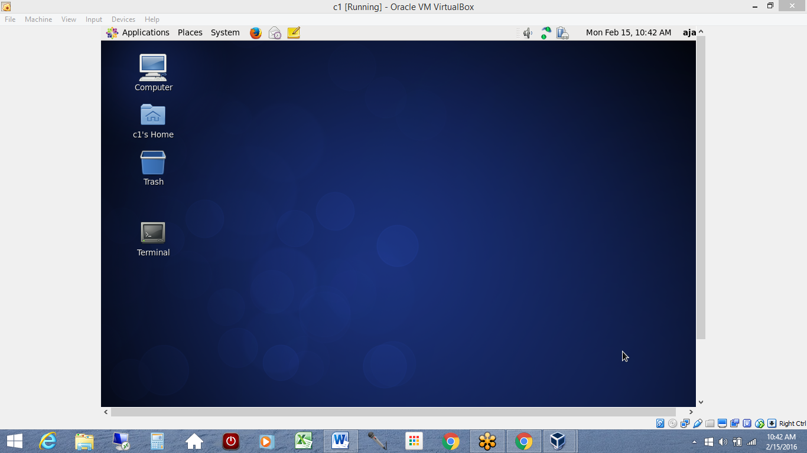

Go to Applications>system tools>terminal

You might logged in as ur username

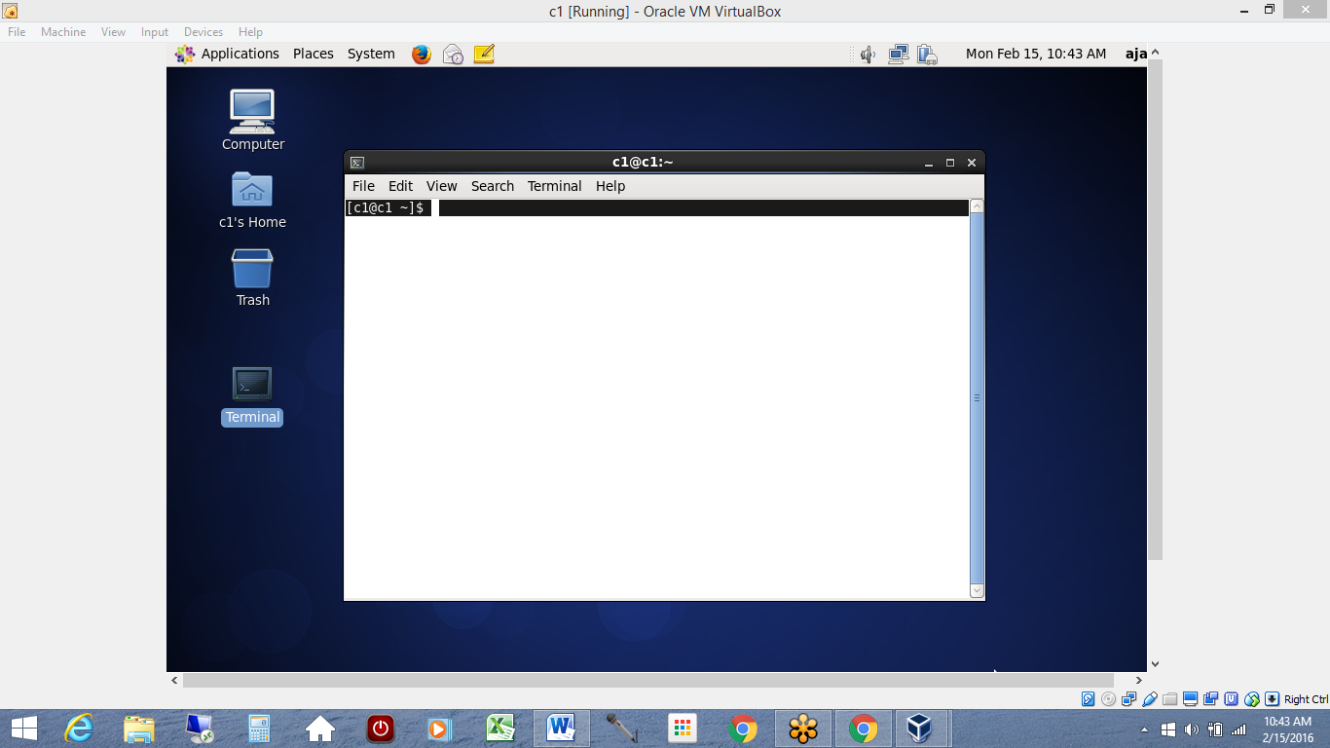

Login as root

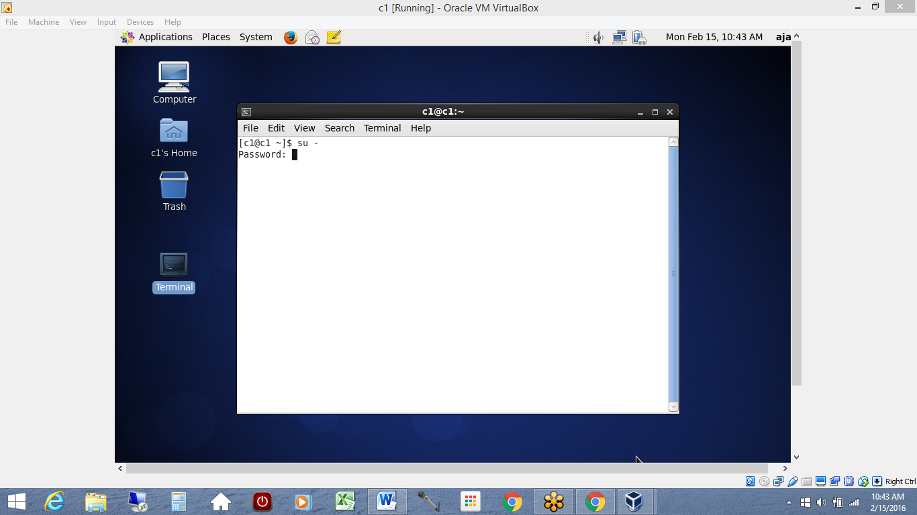

Do a Ifconfig and check ur ipaddress.

Since we used bridge adapter each machine would have different Ip address.

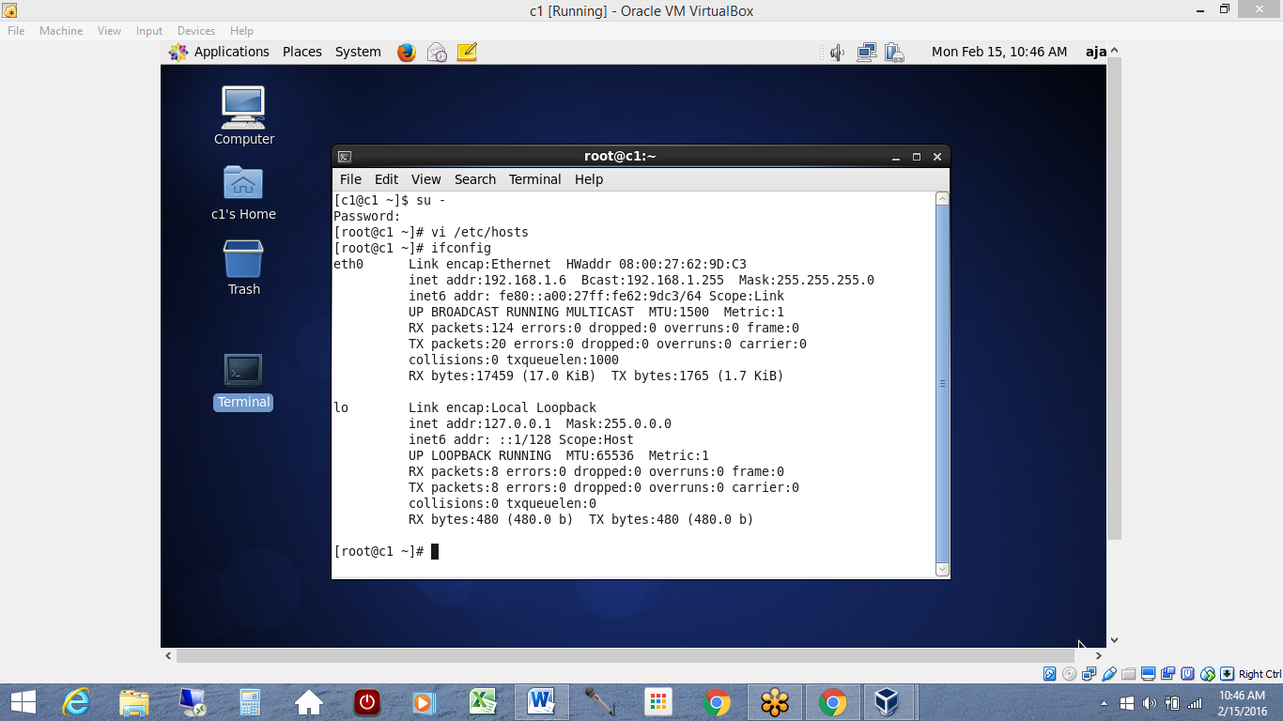

Go to /etc/hosts and update your ip address and fully qualified domain name

In my case I gave domain name as c1.xyz.com and so on.

You can give domain names as per your organization and also update ur Ip address of all machines and save it.

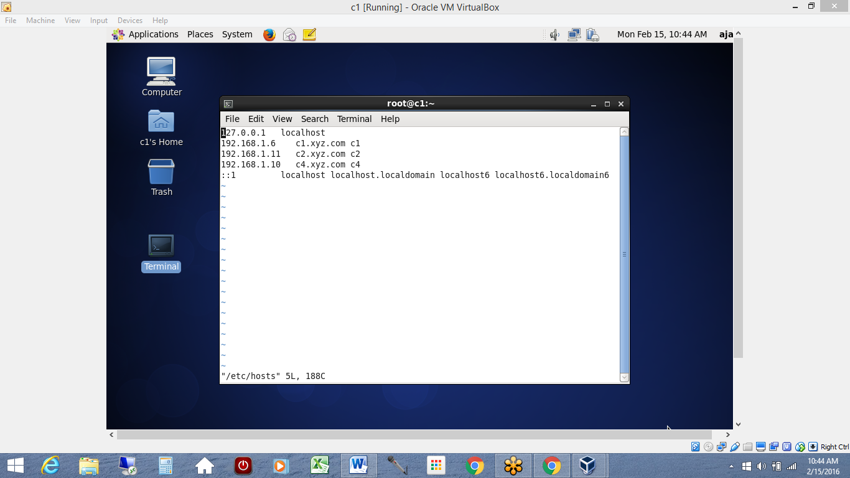

This needs to be done in all machines and then you can test your ping and see if each machine pings each machine.

Establish SSH in all machines.

So you need to install openssh-server in all machines.

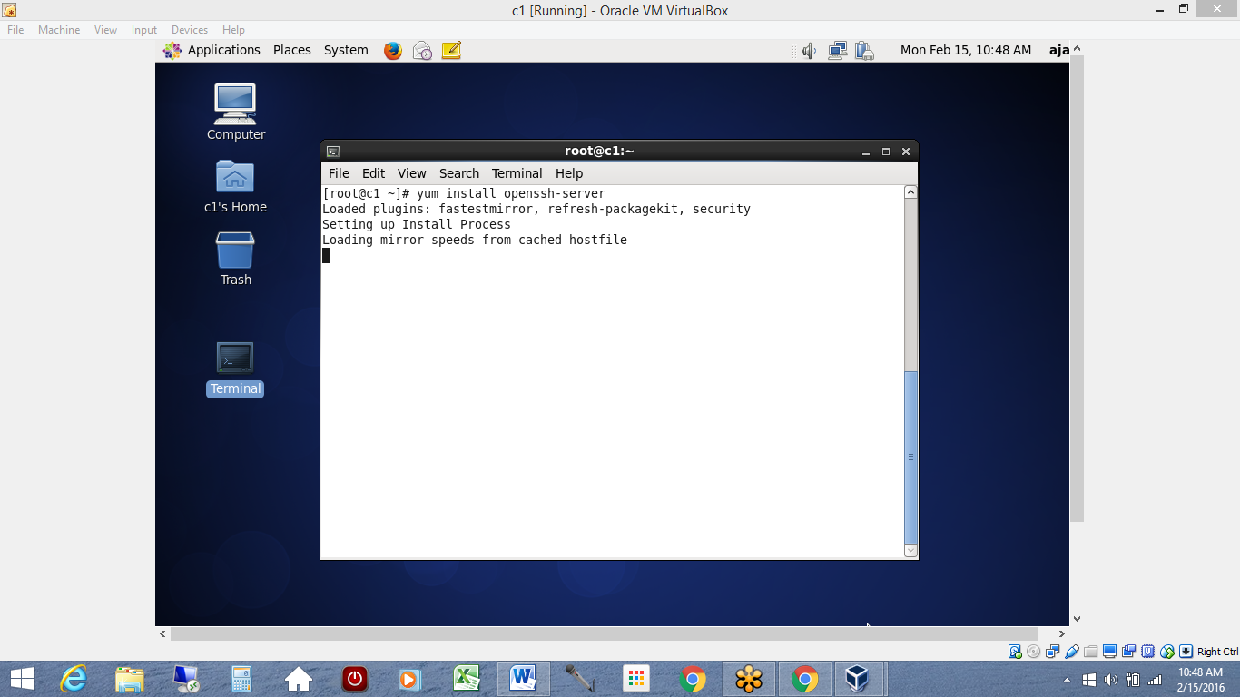

Once done

We need to generate SSH keys in each machine for ROOT

Command is **ssh-keygen –t rsa –P “”**

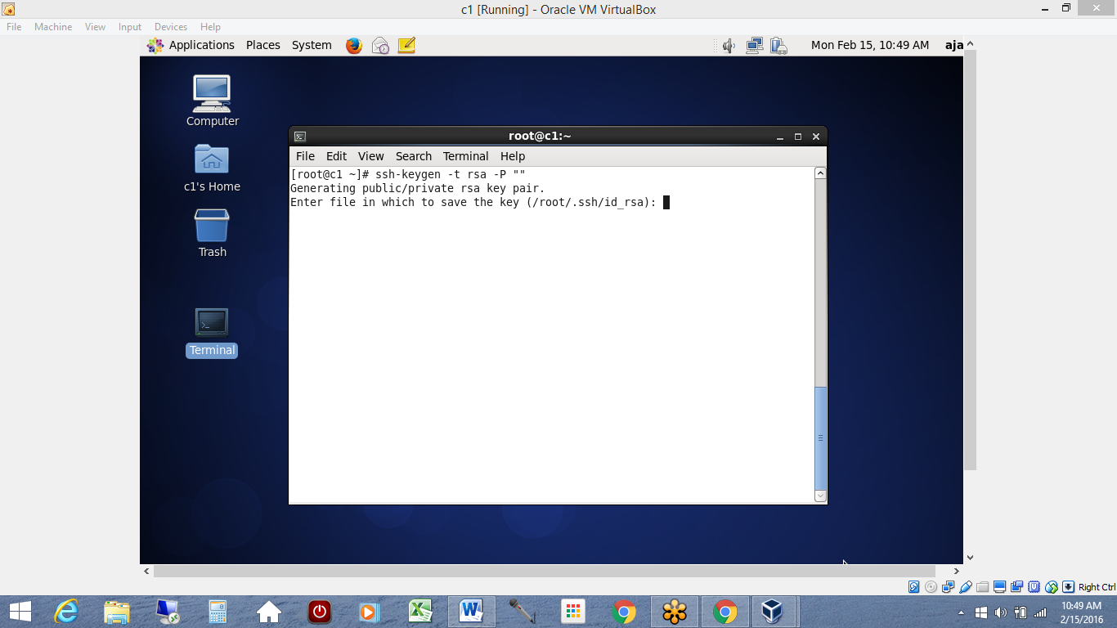

Hit enter

And this would save ssh public and private keys in ur machines home directory for root i.e. in /root

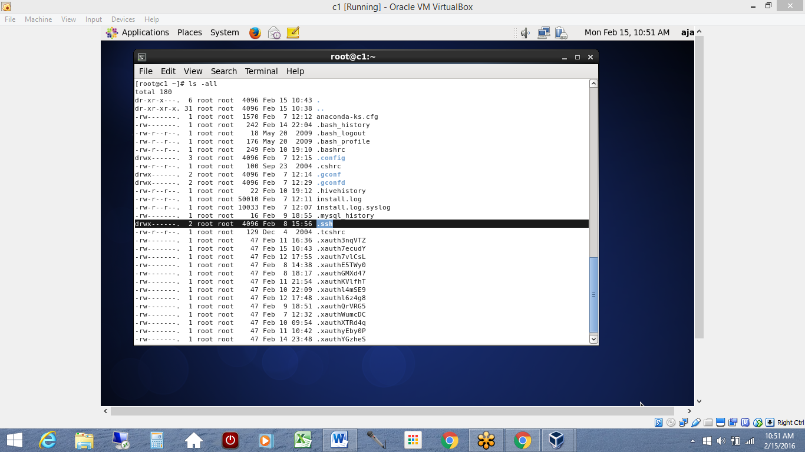

Looking in .ssh shows

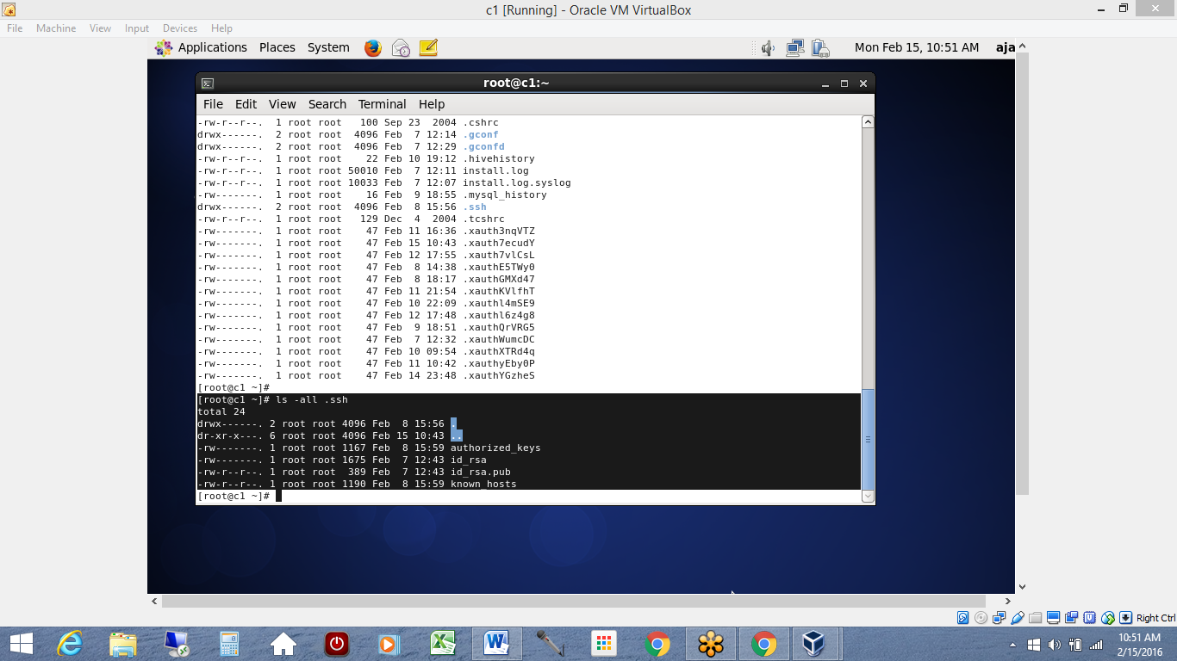

You might not see authorized_keys and known_hosts and that’s ok.

These will get created when you distribute your public keys to other machines and your local machine.

To copy your **id_rsa.pub** to other machines and from other machines to your machine

**root@machine1$ssh-copy-id – I $HOME/.ssh/id_rsa.pub root@machine2**

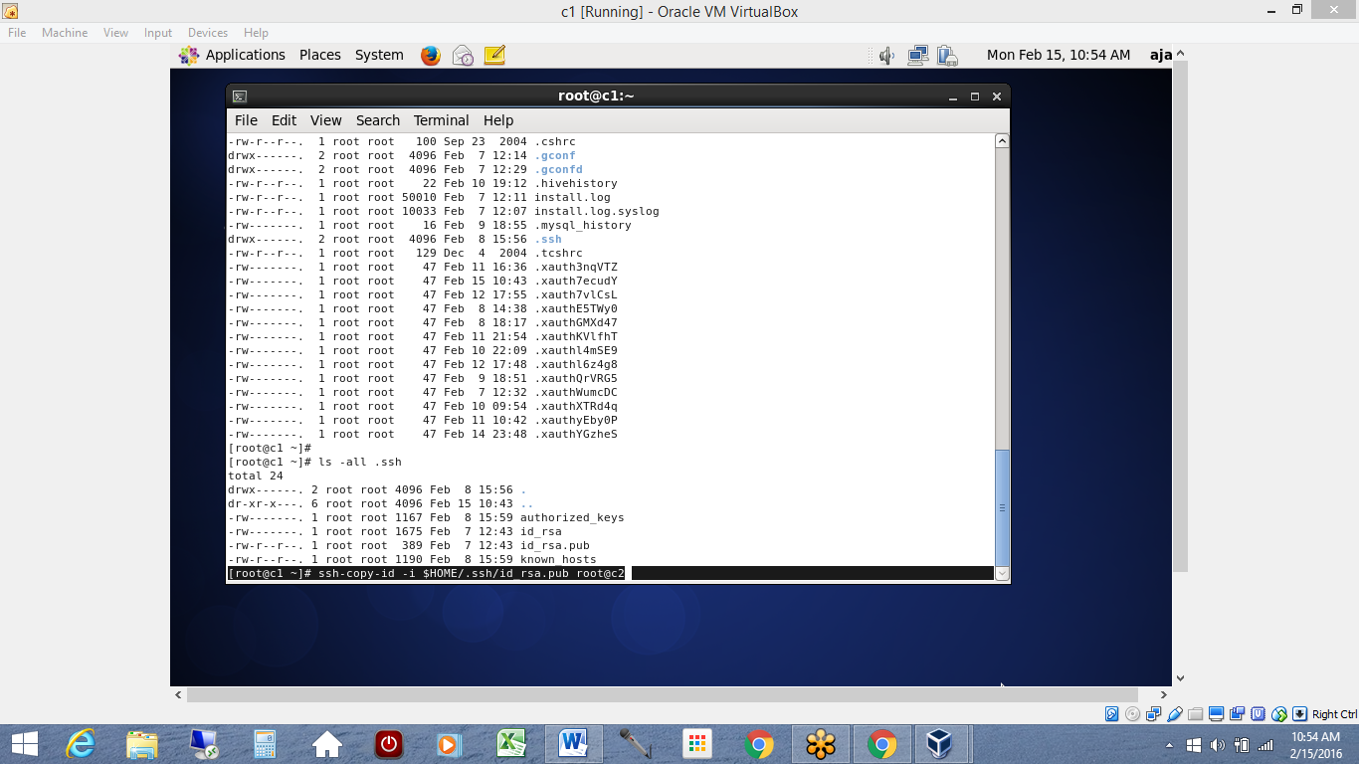

Similarly do from all machines to all machines.

Finally you would see ‘authorized_keys’ and ‘known_hosts’ in all machines in **.ssh** directory

Finally do this in all machines

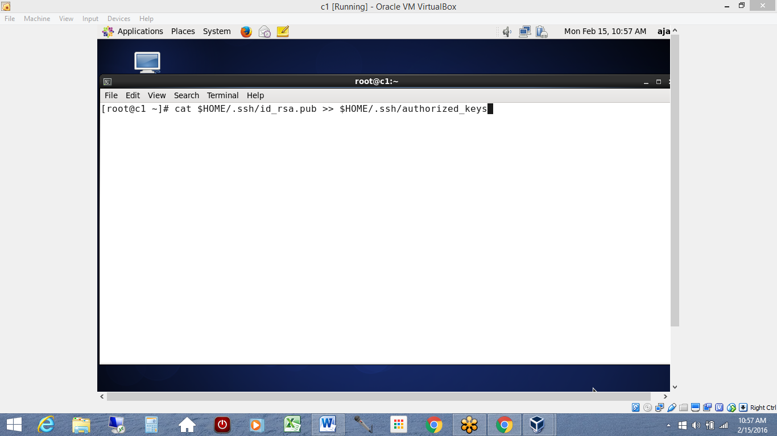

Now test your ssh access from all machines to machines.

Your multiple machines are ready to be used.